First-Year Advising & Registration Guidebook

Major in Biology

Your First-Year Advising & Registration (FYAR) Guidebook will help you identify classes of interest for your first semester at Elon University. Use this with your online preorientation, Elon Bound. You will also want to spend time on the FYAR section of the Office of Academic Advising website where you will find video tutorials and frequently asked questions.

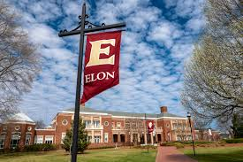
Your FYAR Guidebook provides information for recommended classes in your area of academic exploration. Read this information carefully and complete the worksheet section of the guidebook before attending your small group virtual advising meeting.

Recommended Courses: Biology
Your first semester schedule will consist of the following:
- ELN 1010: First Year Advising Seminar (required)
- COR 1100 OR ENG 1100 (required)

Biology Course Options:
- One Biology course - choose between:
  - BIO 1112/1113: Introductory Cell Biology with Lab
  - BIO 1514 Biodiversity
Recommended:
- CHM 1110/CHML 1110: General Chemistry I with Lab
  - strongly recommended in first semester for health profession or biomedical research career paths, can be taken in second year if student is interested in ecology or more field biology related areas
Additional Options:
Select 1 to 2 classes from:
- STS 2120 Statistics in Application (pending Math placement) (it is recommended to take this course during the first year, but not necessarily the first semester)
- Studies in the Arts & Sciences Course
  - (Psychology 1000: Intro to Psychology is a common Society elective for students pursuing a health-oriented career.)
Important Notes:
- AP Chemistry and AP Biology of a 4 or 5 do not result in credit for either CHM/CHML 1110 or BIO 1112/1113. Students will earn LAB 1XXX credit for these courses for the Science/Analysis section of the Elon Core Curriculum.
- Students who do not complete CHM 1110/CHML 1110 in their first semester may need to take summer Chemistry classes in order to complete their degree in four years.
- Biology majors should NOT enroll in either BIO 1012/1013 or BIO 1064.
Your goal is to register for 16-18 semester hours for the upcoming semester, with 17 semester hours being the most common course load.
Alternate classes are critical so plan for at least 8 classes of interest that can be taken in your first semester or would be of interest for a future term.

Building Your Schedule Worksheet
Complete this worksheet to determine classes of interest for your first semester at Elon. You should have a minimum of 10 classes of interest to consider. This will best enable you to create a schedule with both class interests and times that are most effective for your learning.
- Circle/highlight the class you are pre-enrolled in. You will complete both courses, 1 in the fall and the other in the spring. | - COR 1100: The Global Experience  - ENG 1100: Writing – Argument & Inquiry
- Are you undecided on what major to pursue? Consider enrolling in Enroll in ELN 1110: Exploring Majors for 1 semester hour. | Circle level of interest:  Yes  No
- Enter your ELN 1010 course time in the box to the right. Check your schedule in OnTrack.
- How many credits do you want to take this semester? Overall, 17 credits is the most common. A minimum of 12 is needed to be full-time. First semester students enrolled in ELN 1010 can enroll in up to 19.
- My Math Placement is (check your Timeline in OnTrack):
- Do you want to take First-Year Foundations Math this semester?
- My World Language Placement is (check your Timeline in OnTrack):
- Do you want/need to take a World Language your first semester?
- What intro to major classes interest you? Be sure to list both the major and the class so you can keep track of which classes connect to which major(s). (View page 2 of this document.)
- What courses in Expression did you look up in OnTrack and find interesting?
- What courses in Civilization did you look up in OnTrack and find interesting?
- What courses in Society did you look up in OnTrack and find interesting?
- What courses in Science did you look up in OnTrack and find interesting?
- Note questions you plan to ask during your virtual advising session.

Major Example Schedule 1

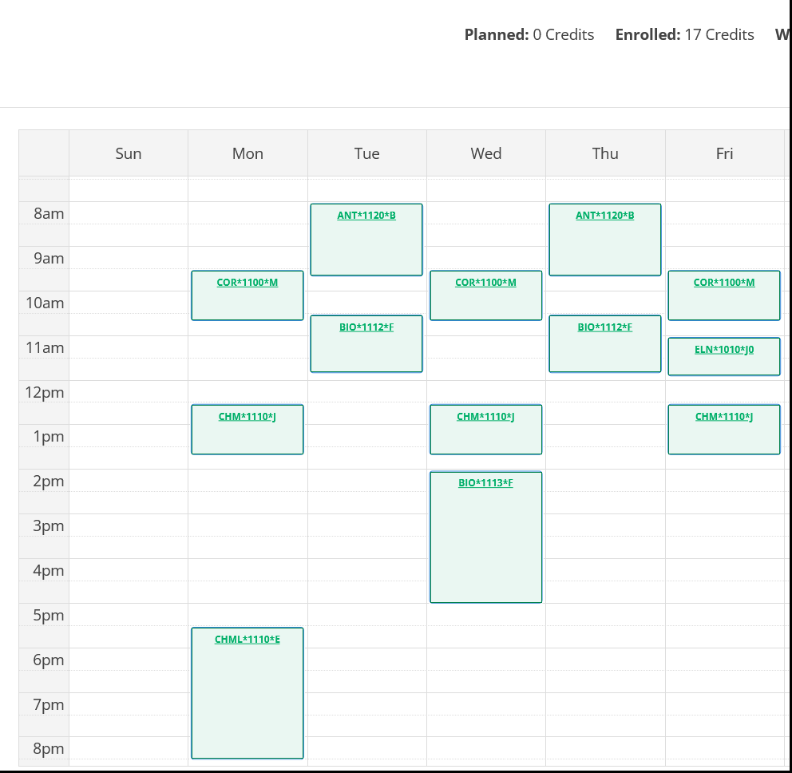
Course List of 17 semester hours:
- ELN 1010 – required
- BIO 1112/1113 – required for major and counts as Science/Analysis in the Elon Core Curriculum
- CHM 1110 and CHML 1110 – required for major and counts as Science/Analysis required lab in the Elon Core Curriculum
- COR 1100 – required First-Year Foundations writing/discussion course
- ANT 1120 – counts as a Society elective

Major Example Schedule 2

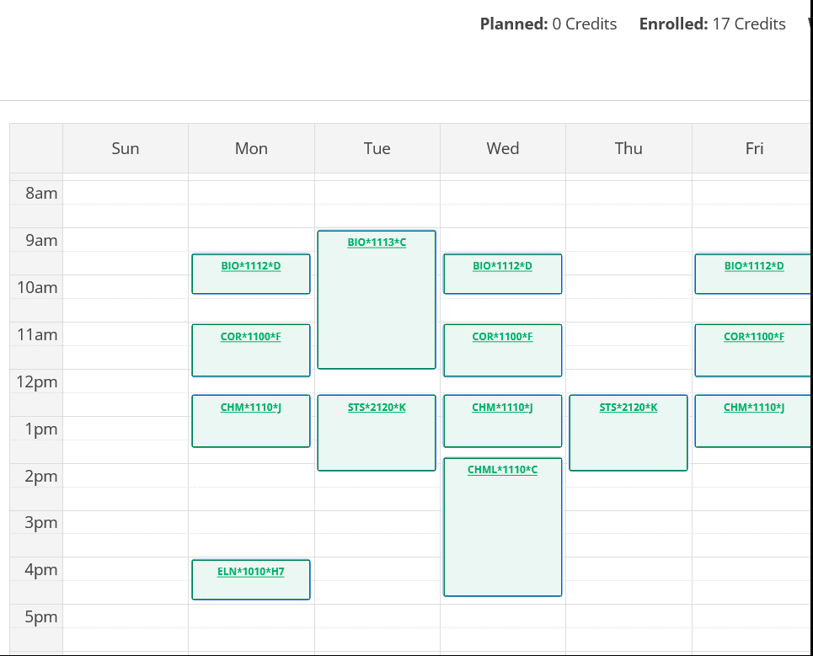
Course List of 17 semester hours:
- ELN 1010 – required
- BIO 1112/1113 – required for major and counts as Science/Analysis in the Elon Core Curriculum
- CHM 1110 and CHML 1110 – required for major and counts as Science/Analysis required lab in the Elon Core Curriculum
- COR 1100 – required First-Year Foundations writing/discussion course
- STS 2120 – required for major and counts as First-Year Foundations Math in the Elon Core Curriculum

