First-Year Advising & Registration Guidebook

Major in Chemistry

Your First-Year Advising & Registration (FYAR) Guidebook will help you identify classes of interest for your first semester at Elon University. Use this with your online preorientation, Elon Bound. You will also want to spend time on the FYAR section of the Office of Academic Advising website where you will find video tutorials and frequently asked questions.

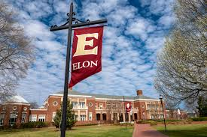
Your FYAR Guidebook provides information for recommended classes in your area of academic exploration. Read this information carefully and complete the worksheet section of the guidebook before attending your small group virtual advising meeting.

Recommended Courses: Chemistry
Your first semester schedule will consist of the following:
- ELN 1010: First Year Advising Seminar (required)
- COR 1100 OR ENG 1100 (required)
The following classes are strongly recommended in the first semester:
- Chemistry (CHM) 1110: General Chemistry I with concurrent enrollment in Chemistry Lab (CHML) 1110: General Chemistry Lab I
- Math (MTH) 1510: Calculus I, pending Math Placement
  - Start with Statistics (STS) 1100: Intro to Statistical Reasoning if this is the math placement
  - Students with MTH 1510 credit pursuing the Bachelor of Science in Chemistry should consider enrolling in MTH 2510: Calculus II
Additional Options:
Select 1 to 2 classes from:
- Studies in the Arts & Sciences Course from Expression, Civilization, or Society
- World Language requirement, pending World Language placement
- Physics Sequence:
  - PHY 2010: General Physics I with Lab
  - PHY 2210: University Physics I (lab is integrated into class time)

Important Information!
Students who do not complete CHM 1110/CHML 1110 in their first semester will likely need to take summer Chemistry classes in order to complete their degree in four years.
AP Chemistry of a 4 or 5 does not result in credit for CHM/CHML 1110.

Your goal is to register for 16-18 semester hours for the upcoming semester, with 17 semester hours being the most common course load.
Alternate classes are critical so plan for at least 8 classes of interest that can be taken in your first semester or would be of interest for a future term.
Building Your Schedule Worksheet
Complete this worksheet to determine classes of interest for your first semester at Elon. You should have a minimum of 10 classes of interest to consider. This will best enable you to create a schedule with both class interests and times that are most effective for your learning.
- Circle/highlight the class you are pre-enrolled in. You will complete both courses, 1 in the fall and the other in the spring. | - COR 1100: The Global Experience  - ENG 1100: Writing – Argument & Inquiry
- Are you undecided on what major to pursue? Consider enrolling in Enroll in ELN 1110: Exploring Majors for 1 semester hour. | Circle level of interest:  Yes  No
- Enter your ELN 1010 course time in the box to the right. Check your schedule in OnTrack.
- How many credits do you want to take this semester? Overall, 17 credits is the most common. A minimum of 12 is needed to be full-time. First semester students enrolled in ELN 1010 can enroll in up to 19.
- My Math Placement is (check your Timeline in OnTrack):
- Do you want to take First-Year Foundations Math this semester?
- My World Language Placement is (check your Timeline in OnTrack):
- Do you want/need to take a World Language your first semester?
- What intro to major classes interest you? Be sure to list both the major and the class so you can keep track of which classes connect to which major(s). (View page 2 of this document.)
- What courses in Expression did you look up in OnTrack and find interesting?
- What courses in Civilization did you look up in OnTrack and find interesting?
- What courses in Society did you look up in OnTrack and find interesting?
- What courses in Science did you look up in OnTrack and find interesting?
- Note questions you plan to ask during your virtual advising session.

Chemistry Major Schedule Example 1

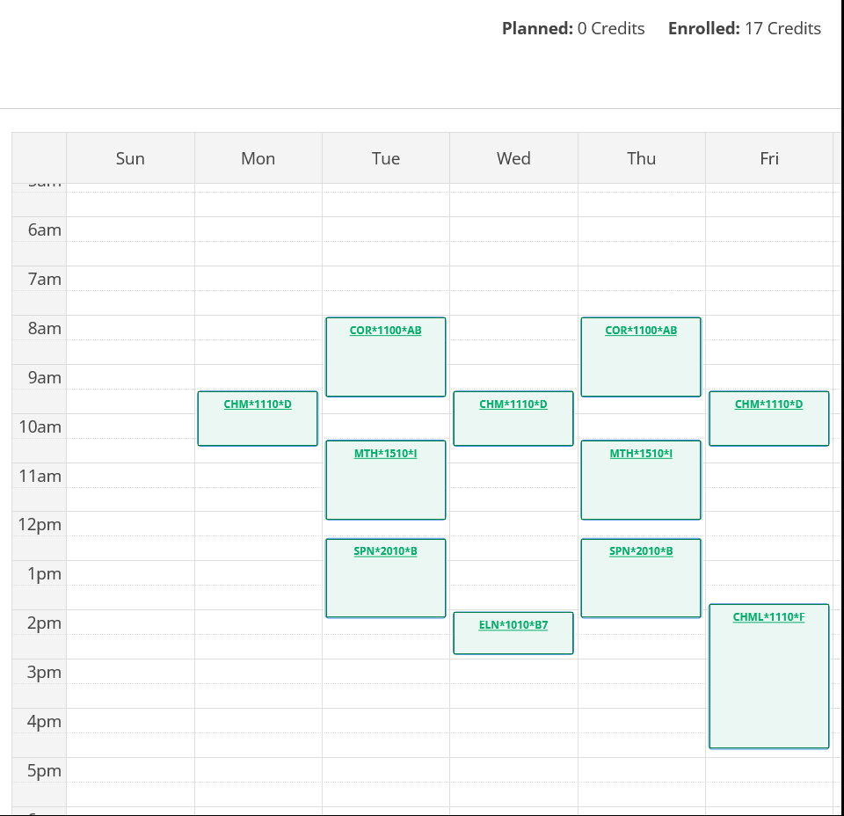
Course List of 17 semester hours:
- ELN 1010 – required
- CHM 1110 and CHML 1110 – required for major and counts as Science/Analysis required lab in the Elon Core Curriculum
- COR 1100 – required First-Year Foundations writing/discussion course
- MTH 1510 – required for major and counts as First-Year Foundations Math
- SPN 2010 – counts as a Civilization elective

Chemistry Major Schedule Example 2

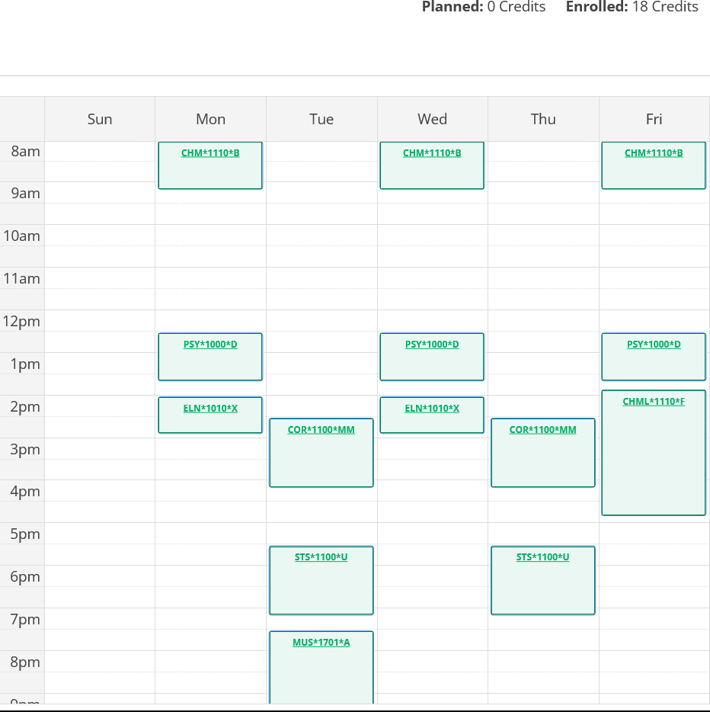
Course List of 18 semester hours:
- ELN 1010 – required
- CHM 1110 and CHML 1110 – required for major and counts as Science/Analysis required lab in the Elon Core Curriculum
- COR 1100 – required First-Year Foundations writing/discussion course
- STS 1100 – required First-Year Foundations Math based on placement result
- PSY 1000 – counts as a Society elective
- MUS 1701 (Concert Band) – 1 semester hour class that counts towards Expression

