First-Year Advising & Registration Guidebook

Department of Music
Major Options in Music:
- *Music Performance A.B.:
- *Music Education B.S.:
- *Music Production & Recording Arts B.S.:
- Music in Liberal Arts A.B.
(*Requires an audition or portfolio for acceptance.)

Your First-Year Advising & Registration (FYAR) Guidebook will help you identify classes of interest for your first semester at Elon University. Use this with your online preorientation, Elon Bound. You will also want to spend time on the FYAR section of the Office of Academic Advising website where you will find video tutorials and frequently asked questions.

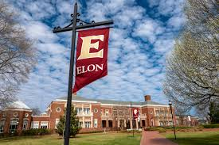
Your FYAR Guidebook provides information for recommended classes in your area of academic exploration. Read this information carefully and complete the worksheet section of the guidebook before attending your small group virtual advising meeting.

Department of Music Majors
Your first semester schedule will consist of the following:
- ELN 1010: First Year Advising Seminar (required)
- COR 1100 OR ENG 1100 (required)
Common Requirements:
- Music (MUS) 1310: Materials of Music I with Music (MUS) 1315: Aural Skills I
- Students with AP or transfer credit may advance to MUS 1320: Materials of Music I with MUS 1325: Aural Skills II based on course availability
Additional Options by major:
Music Education:
- Sociology (SOC) 2430: Sociology of Education
- Music (MUS) 2510: Diction for Singers
Music Performance:
- Applied music lessons, as approved by the department
- Ensembles, as approved by the department
Music Production & Recording Arts:
- Music (MUS) 1051: Chorale
- Music (MUS) 2825: Introduction to Music Technology
Select 1 to 2 classes from:
- First-Year Foundations Math based on placement result
- World Language course as needed, based on World Language placement result
- Studies in the Arts & Sciences Courses from Civilization or Society

Your goal is to register for 16-18 semester hours for the upcoming semester, with 17 semester hours being the most common course load.
Alternate classes are critical so plan for at least 8 classes of interest that can be taken in your first semester or would be of interest for a future term.

Building Your Schedule Worksheet
Complete this worksheet to determine classes of interest for your first semester at Elon. You should have a minimum of 10 classes of interest to consider. This will best enable you to create a schedule with both class interests and times that are most effective for your learning.
- Circle/highlight the class you are pre-enrolled in. You will complete both courses, 1 in the fall and the other in the spring. | - COR 1100: The Global Experience  - ENG 1100: Writing – Argument & Inquiry
- Are you undecided on what major to pursue? Consider enrolling in Enroll in ELN 1110: Exploring Majors for 1 semester hour. | Circle level of interest:  Yes  No
- Enter your ELN 1010 course time in the box to the right. Check your schedule in OnTrack.
- How many credits do you want to take this semester? Overall, 17 credits is the most common. A minimum of 12 is needed to be full-time. First semester students enrolled in ELN 1010 can enroll in up to 19.
- My Math Placement is (check your Timeline in OnTrack):
- Do you want to take First-Year Foundations Math this semester?
- My World Language Placement is (check your Timeline in OnTrack):
- Do you want/need to take a World Language your first semester?
- What intro to major classes interest you? Be sure to list both the major and the class so you can keep track of which classes connect to which major(s). (View page 2 of this document.)
- What courses in Expression did you look up in OnTrack and find interesting?
- What courses in Civilization did you look up in OnTrack and find interesting?
- What courses in Society did you look up in OnTrack and find interesting?
- What courses in Science did you look up in OnTrack and find interesting?
- Note questions you plan to ask during your virtual advising session.

Music Production and Recording Arts Schedule Example
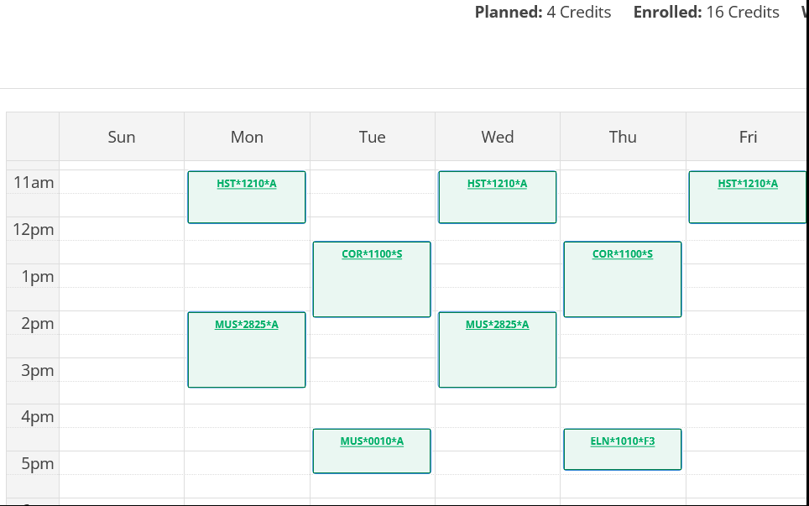
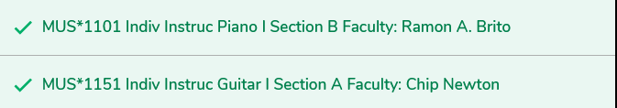
Course List of 17 semester hours:
- ELN 1010 – required
- COR 1100 – required in either fall or spring
- MUS 0010A – Major
- MUS 2825 – Major + Expression
- ARH 1702 – Civilization
- MUS 1101 – Major (lesson)
- MUS 1151 – Major (lesson)

Note: please be aware that costs for individual instruction/lessons is an additional cost above that of tuition.

Music Performance Schedule Example
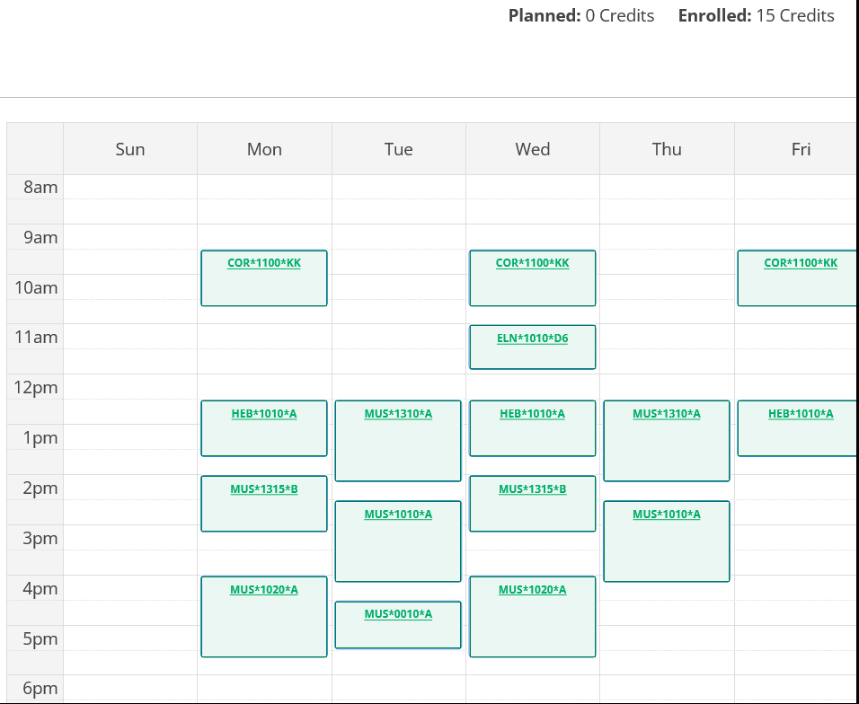
Course list of 15 credit hours:
- ELN 1010 – required
- COR 1100 – required in either fall or spring
- MUS 0010A – Major
- MUS 1310/1315 – Major + Expression
- MUS 1010 – Major ensemble
- MUS 1020 – Major
- HEB 1010 – Civilization

Note: Music majors often take 1 and 2 semester hour courses that lead to a more packed schedule. Some students will opt to take 15 or 16 semester hours on occasion as a result.

