First-Year Advising & Registration Guidebook

Love School of Business Majors

Your First-Year Advising & Registration (FYAR) Guidebook will help you identify classes of interest for your first semester at Elon University. Use this with your online preorientation, Elon Bound. You will also want to spend time on the FYAR section of the Office of Academic Advising website where you will find video tutorials and frequently asked questions.

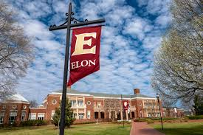
Your FYAR Guidebook provides information for recommended classes in your area of academic exploration. Read this information carefully and complete the worksheet section of the guidebook before attending your small group virtual advising meeting.

Recommended Courses: Love School of Business
Between 25-30% of the Class of 2028 has an interest in the Love School of Business. We encourage students to enroll in no more than 1-2 of the courses listed for LSB majors below and complete the remainder of the schedule with Elon Core Curriculum or other intro to major classes to compare to LSB options. Some students will focus exclusively on Elon Core Curriculum requirements and remain on pace to graduate in four years.
Your first semester schedule will consist of the following:
- ELN 1010: First Year Advising Seminar (required)
- COR 1100 OR ENG 1100 (required)
All LSB Majors must complete the following courses:
- Economics (ECO) 1000: Principles of Economics
- *Math (MTH) 1160: Applied Calculus or *MTH 1510: Calculus I
- *Statistics (STS) 2120: Statistics in Application or +Economics (ECO) 2300: Statistics for Decision-Making
*Indicates Math Placement is needed for course enrollment.
+Indicates completion of First-Year Foundations Math is needed for course enrollment.
Additional Common Requirements (all except Economics):
- Business Administration (BUS) 1110: Gateway to Business
Note: BUS 1110 is typically completed in the second or third full semester.
International Business or International Economics:
- Enroll in a World Language as soon as possible (take WL placement first)
- Students pursuing the International Business Dual Degree program must enroll in a World Language in their first semester.
Additional Course Options:
- World Language course as needed, based on World Language placement result
- Studies in the Arts & Sciences in Expression, Civilization, or Science with lab course
Your goal is to register for 16-18 semester hours for the upcoming semester, with 17 semester hours being the most common course load.
Alternate classes are critical so plan for at least 8 classes of interest that can be taken in your first semester or would be of interest for a future term.

Building Your Schedule Worksheet
Complete this worksheet to determine classes of interest for your first semester at Elon. You should have a minimum of 10 classes of interest to consider. This will best enable you to create a schedule with both class interests and times that are most effective for your learning.
- Circle/highlight the class you are pre-enrolled in. You will complete both courses, 1 in the fall and the other in the spring. | - COR 1100: The Global Experience  - ENG 1100: Writing – Argument & Inquiry
- Are you undecided on what major to pursue? Consider enrolling in Enroll in ELN 1110: Exploring Majors for 1 semester hour. | Circle level of interest:  Yes  No
- Enter your ELN 1010 course time in the box to the right. Check your schedule in OnTrack.
- How many credits do you want to take this semester? Overall, 17 credits is the most common. A minimum of 12 is needed to be full-time. First semester students enrolled in ELN 1010 can enroll in up to 19.
- My Math Placement is (check your Timeline in OnTrack):
- Do you want to take First-Year Foundations Math this semester?
- My World Language Placement is (check your Timeline in OnTrack):
- Do you want/need to take a World Language your first semester?
- What intro to major classes interest you? Be sure to list both the major and the class so you can keep track of which classes connect to which major(s). (View page 2 of this document.)
- What courses in Expression did you look up in OnTrack and find interesting?
- What courses in Civilization did you look up in OnTrack and find interesting?
- What courses in Society did you look up in OnTrack and find interesting?
- What courses in Science did you look up in OnTrack and find interesting?
- Note questions you plan to ask during your virtual advising session.

Love School of Business Example Schedule 1
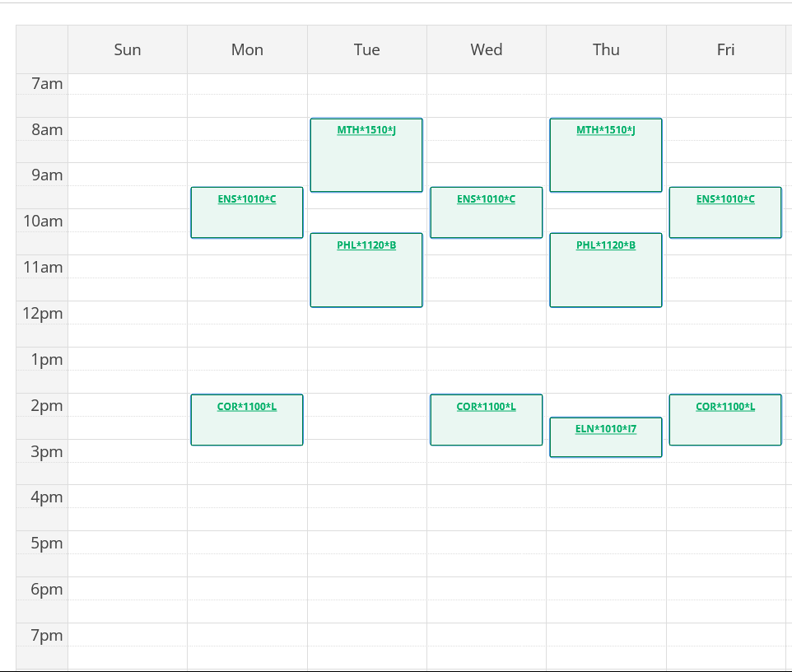

Course List of 17 semester hours:

- ELN 1010 – required
- COR 1100 – required in either fall or spring
- MTH 1510 – counts for required First-Year Foundations Math and for LSB major
- PHL 1120 – counts for Expression
- ENS 1010 – counts as Science/Analysis as a Non-Lab Science

Love School of Business Example Schedule 2
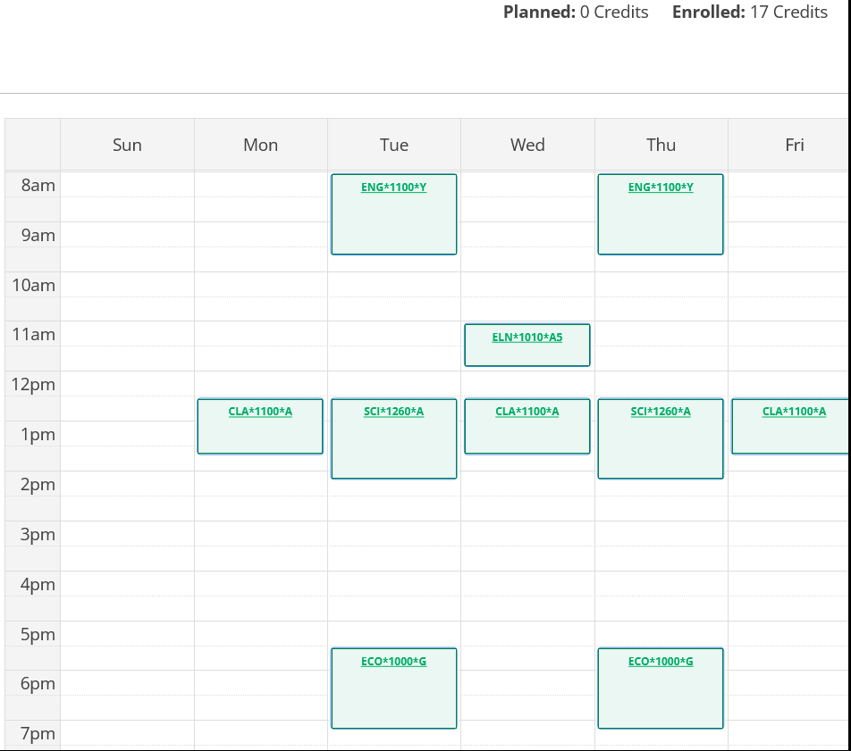

Course List of 17 semester hours:

- ELN 1010 – required
- ENG 1100 – required in either fall or spring
- ECO 1000 – Major + Society
- CLA 1100 – Civilization
- SCI 1260 – Science/Analysis Non-Lab Science

