First-Year Advising & Registration Guidebook

School of Health Sciences: Nursing

Your First-Year Advising & Registration (FYAR) Guidebook will help you identify classes of interest for your first semester at Elon University. Use this with your online preorientation, Elon Bound. You will also want to spend time on the FYAR section of the Office of Academic Advising website where you will find video tutorials and frequently asked questions.

Your FYAR Guidebook provides information for recommended classes in your area of academic exploration. Read this information carefully and complete the worksheet section of the guidebook before attending your small group virtual advising meeting.

Recommended Courses: Nursing
Students must be admitted into the Nursing major either through the Admissions process in joining Elon University; or, space permitting, through lateral entry after starting their time at Elon.
The Nursing Department does not require any Nursing (NRS) courses in the initial academic year. The first year is foundational and critical to assist students in their future coursework.
Required First Semester Courses
- ELN 1010: First Year Advising Seminar (Nursing cohort)
- COR 1100 OR ENG 1100 (required)
- Psychology (PSY) 1000: Intro to Psychology
- Biology (BIO) 1112: Cell Biology with BIO 1113: Cell Bio lab
- Based on Math placement, one of:
  - Statistics (STS) 1100: Intro to Statistical Reasoning; or,
  - STS 2120: Statistics in Application
Students not admitted to Nursing but pursuing this path may enroll in the course above. They will, however, be registered for an ELN 1010 section that is not just Nursing students. This will not impact the pursuit of this major.
Course Options based on Incoming Credit
PSY 1000 credit | Enroll in PSY 2100: Developmental Psychology or Studies in the Arts & Sciences course in Expression, World Language/Civilization, other Civilization, or a Society class outside of Psychology
Statistics credit | Enroll in Studies in the Arts & Sciences course in Expression, World Language/Civilization, other Civilization, or a Society class outside of Psychology
BIO 1112/1113 credit | Consider enrollment in one of:  - BIO 2312/2313: Human Anatomy with Lab; or,  - BIO 2412/2413: Human Physiology with Lab

Your goal is to register for 16-18 semester hours for the upcoming semester, with 17 semester hours being the most common course load.
Alternate classes are critical so plan for at least 8 classes of interest that can be taken in your first semester or would be of interest for a future term.
Building Your Schedule Worksheet
Complete this worksheet to determine classes of interest for your first semester at Elon. You should have a minimum of 10 classes of interest to consider. This will best enable you to create a schedule with both class interests and times that are most effective for your learning.
- Circle/highlight the class you are pre-enrolled in. You will complete both courses, 1 in the fall and the other in the spring. | - COR 1100: The Global Experience  - ENG 1100: Writing – Argument & Inquiry
- Are you undecided on what major to pursue? Consider enrolling in Enroll in ELN 1110: Exploring Majors for 1 semester hour. | Circle level of interest:  Yes  No
- Enter your ELN 1010 course time in the box to the right. Check your schedule in OnTrack.
- How many credits do you want to take this semester? Overall, 17 credits is the most common. A minimum of 12 is needed to be full-time. First semester students enrolled in ELN 1010 can enroll in up to 19.
- My Math Placement is (check your Timeline in OnTrack):
- Do you want to take First-Year Foundations Math this semester?
- My World Language Placement is (check your Timeline in OnTrack):
- Do you want/need to take a World Language your first semester?
- What intro to major classes interest you? Be sure to list both the major and the class so you can keep track of which classes connect to which major(s). (View page 2 of this document.)
- What courses in Expression did you look up in OnTrack and find interesting?
- What courses in Civilization did you look up in OnTrack and find interesting?
- What courses in Society did you look up in OnTrack and find interesting?
- What courses in Science did you look up in OnTrack and find interesting?
- Note questions you plan to ask during your virtual advising session.

Nursing Example Schedule 1

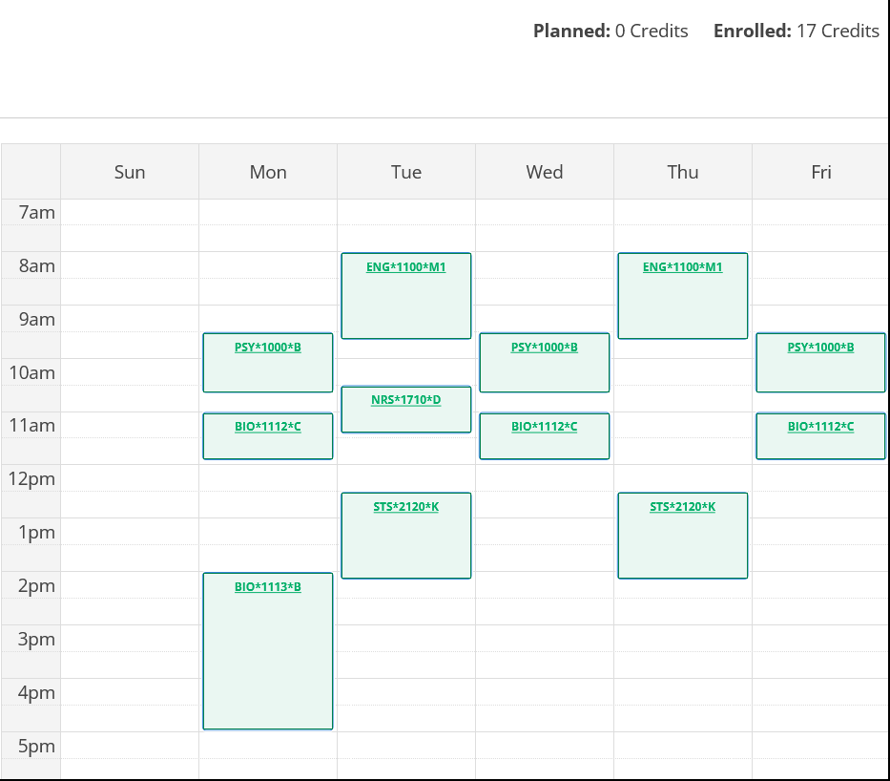
Course List of 17 semester hours:
- NRS 1710/– required (this was NRS 1710 in fall 2023 but is now ELN 1010)
- ENG 1100 – required in either fall or spring
- STS 2120 – First-Year Foundations Math + Major
- PSY 1000 – Society + Major
- BIO 1112/1113 – Lab Science + Major

Major Example Schedule 2
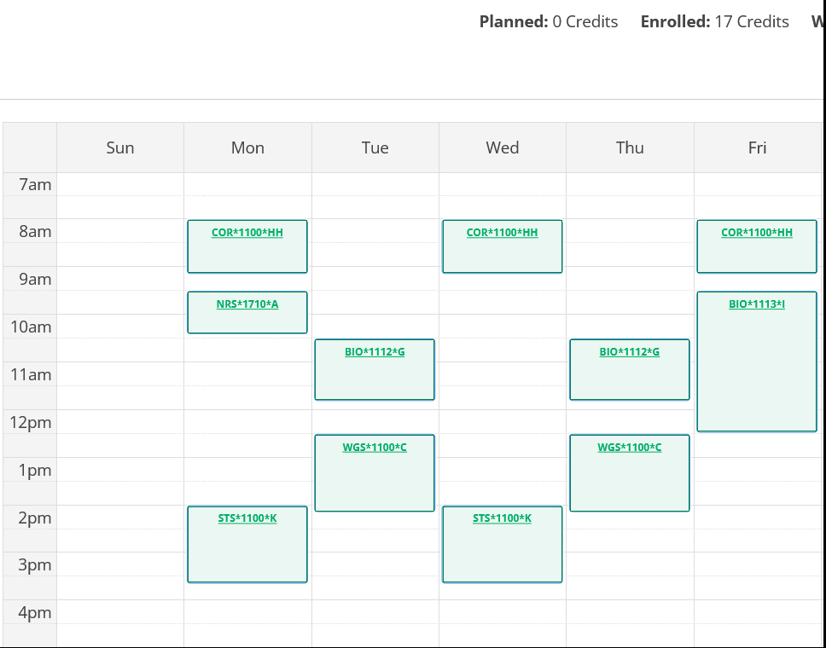
Course List of 17 semester hours:
- NRS 1710/– required (this was NRS 1710 in fall 2023 but is now ELN 1010)
- COR 1100 – required in either fall or spring
- STS 1100 – First-Year Foundations Math + Major
- BIO 1112/1113 – Lab Science + Major
- WGS 1100 – Civilization

Note: This student earned credit for PSY 1000 through Advanced Placement so opted to take a Civilization class in the first semester.

