First-Year Advising & Registration Guidebook

Computer Science


Your First-Year Advising & Registration (FYAR) Guidebook will help you identify classes of interest for your first semester at Elon University. Use this with your online preorientation, Elon Bound. You will also want to spend time on the FYAR section of the Office of Academic Advising website where you will find video tutorials and frequently asked questions.


Your FYAR Guidebook provides information for recommended classes in your area of academic exploration. Read this information carefully and complete the worksheet section of the guidebook before attending your small group virtual advising meeting.

Computer Science
Your first semester schedule will consist of the following:
- ELN 1010: First Year Advising Seminar (required)
- COR 1100 OR ENG 1100 (required)

Computer Science Course Options:
- Computer Science (CSC) 1300: Computer Science I
- Mathematics (MTH) 1510: Calculus I
- Statistics (STS) 1100: Intro to Statistical Reasoning or STS 2120: Statistics in Application
Note: Do not take Calculus and Stats together in the first semester
What If:
You have earned credit for CSC 1300? Enroll in CSC 2300: Computer Science II if space available.
You have earned credit for MTH 1510? Enroll in MTH 2410: Discrete Structures if space available
Additional Course Options for the Bachelor of Science only:
Complete a Biology, Chemistry, or Physics two semester lab sequence starting with:
- BIO 1112/1113: Introductory Cell Biology – Cell Biology Lab; or,
- CHM 1110: General Chemistry I with Lab; or,
- PHY 2210: University Physics I (must take MTH 1510 with or before PHY 2210)
Additional Course Options to complete schedule:
- World Language Proficiency course, if necessary
- Studies in the Arts & Sciences Course from Civilization or Science
Your goal is to register for 16-18 semester hours for the upcoming semester, with 17 semester hours being the most common course load.
Alternate classes are critical so plan for at least 8 classes of interest that can be taken in your first semester or would be of interest for a future term.

Building Your Schedule Worksheet
Complete this worksheet to determine classes of interest for your first semester at Elon. You should have a minimum of 10 classes of interest to consider. This will best enable you to create a schedule with both class interests and times that are most effective for your learning.
- Circle/highlight the class you are pre-enrolled in. You will complete both courses, 1 in the fall and the other in the spring. | - COR 1100: The Global Experience  - ENG 1100: Writing – Argument & Inquiry
- Are you undecided on what major to pursue? Consider enrolling in Enroll in ELN 1110: Exploring Majors for 1 semester hour. | Circle level of interest:  Yes  No
- Enter your ELN 1010 course time in the box to the right. Check your schedule in OnTrack.
- How many credits do you want to take this semester? Overall, 17 credits is the most common. A minimum of 12 is needed to be full-time. First semester students enrolled in ELN 1010 can enroll in up to 19.
- My Math Placement is (check your Timeline in OnTrack):
- Do you want to take First-Year Foundations Math this semester?
- My World Language Placement is (check your Timeline in OnTrack):
- Do you want/need to take a World Language your first semester?
- What intro to major classes interest you? Be sure to list both the major and the class so you can keep track of which classes connect to which major(s). (View page 2 of this document.)
- What courses in Expression did you look up in OnTrack and find interesting?
- What courses in Civilization did you look up in OnTrack and find interesting?
- What courses in Society did you look up in OnTrack and find interesting?
- What courses in Science did you look up in OnTrack and find interesting?
- Note questions you plan to ask during your virtual advising session.

Computer Science Example Schedule 1

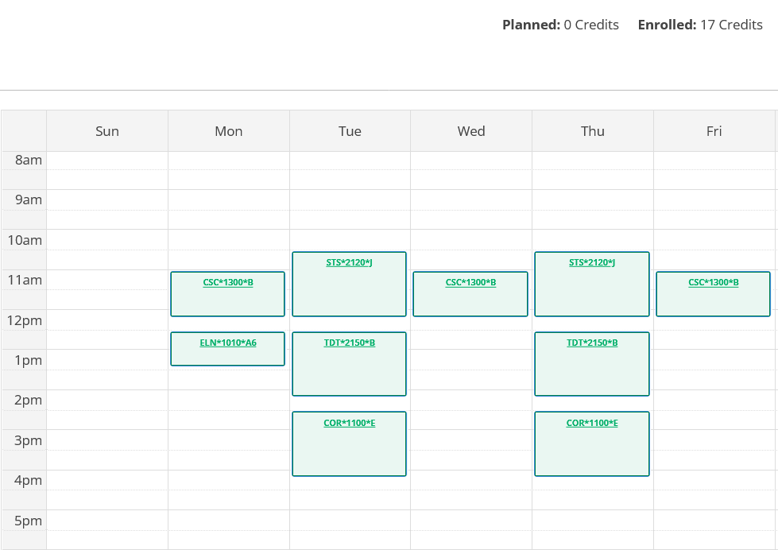
Course List of 17 semester hours:

- ELN 1010 – required
- COR 1100 – required in either fall or spring
- STS 2120 – counts for required First-Year Foundations Math & Computer Science major
- CSC 1300 – Major requirement + Science Non-Lab
- TDT 2150 – Expression

Computer Science Example Schedule 1
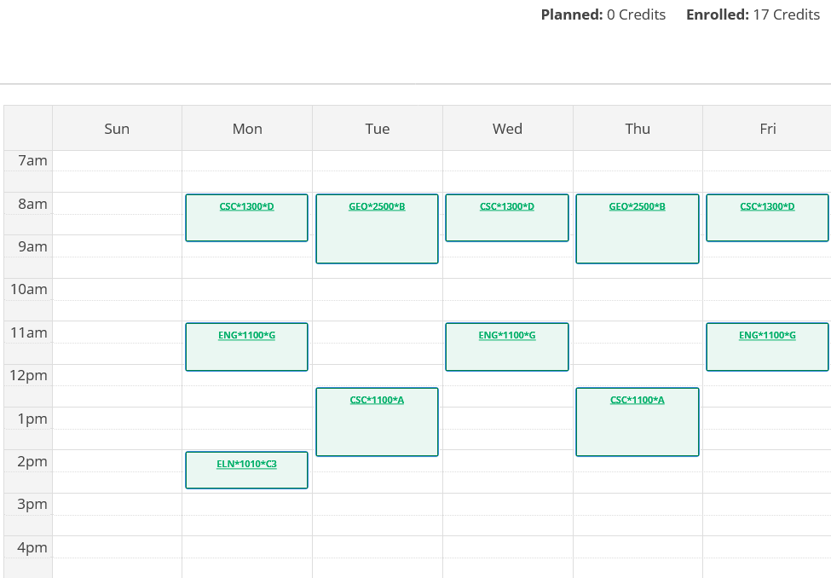

- ELN 1010 – required
- ENG 1100 – required in either fall or spring
- CSC 1100 – required for Data Science minor
- CSC 1300 – required in either fall or spring for Computer Science
- GEO 2500 – Society

Note: This student is pursuing a Computer Science major with a Data Science minor, which is why they have two CSC classes in their first semester.

