First-Year Advising & Registration Guidebook

English
The Department of English allows students to select from the following concentrations: Literature, Creative Writing, Self-Designed and Teacher Licensure. A concentration is a sub-focus of the major.


Your First-Year Advising & Registration (FYAR) Guidebook will help you identify classes of interest for your first semester at Elon University. Use this with your online preorientation, Elon Bound. You will also want to spend time on the FYAR section of the Office of Academic Advising website where you will find video tutorials and frequently asked questions.

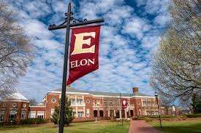
Your FYAR Guidebook provides information for recommended classes in your area of academic exploration. Read this information carefully and complete the worksheet section of the guidebook before attending your small group virtual advising meeting.

Recommended Courses: English A.B.
Your first semester schedule will consist of the following:
- ELN 1010: First Year Advising Seminar (required)
- COR 1100 OR ENG 1100 (required)
Additional Course Options Based on Major:
Literature classes can be difficult to enroll in for the first semester as returning students often fill the courses. The following courses are on track to be offered but may be full prior to class registration:
Literature Options:
- English (ENG) 1223: Dystopian Fictions
- ENG 1232: Literature on the Screen
- ENG 1712: Wilderness and Spiritual
- ENG 1718: Black Speculative Fiction
- ENG 2230: American Literature Before 1800
- ENG 2370: Horror Film and Literature
- ENG 2600: Literature and the Law
Additional Creative Writing Options:
- ENG 2130: Intro to Creative Writing (does not count as Literature or Expression)
Additional Teacher Licensure Options:
- Sociology (SOC) 2430: Sociology of Education
Additional Options:
- First-Year Foundations Math
- World Language Proficiency course, if necessary
- Studies in the Arts & Sciences Course from Civilization or Science

Your goal is to register for 16-18 semester hours for the upcoming semester, with 17 semester hours being the most common course load.
Alternate classes are critical so plan for at least 8 classes of interest that can be taken in your first semester or would be of interest for a future term.

Building Your Schedule Worksheet
Complete this worksheet to determine classes of interest for your first semester at Elon. You should have a minimum of 10 classes of interest to consider. This will best enable you to create a schedule with both class interests and times that are most effective for your learning.
- Circle/highlight the class you are pre-enrolled in. You will complete both courses, 1 in the fall and the other in the spring. | - COR 1100: The Global Experience  - ENG 1100: Writing – Argument & Inquiry
- Are you undecided on what major to pursue? Consider enrolling in Enroll in ELN 1110: Exploring Majors for 1 semester hour. | Circle level of interest:  Yes  No
- Enter your ELN 1010 course time in the box to the right. Check your schedule in OnTrack.
- How many credits do you want to take this semester? Overall, 17 credits is the most common. A minimum of 12 is needed to be full-time. First semester students enrolled in ELN 1010 can enroll in up to 19.
- My Math Placement is (check your Timeline in OnTrack):
- Do you want to take First-Year Foundations Math this semester?
- My World Language Placement is (check your Timeline in OnTrack):
- Do you want/need to take a World Language your first semester?
- What intro to major classes interest you? Be sure to list both the major and the class so you can keep track of which classes connect to which major(s). (View page 2 of this document.)
- What courses in Expression did you look up in OnTrack and find interesting?
- What courses in Civilization did you look up in OnTrack and find interesting?
- What courses in Society did you look up in OnTrack and find interesting?
- What courses in Science did you look up in OnTrack and find interesting?
- Note questions you plan to ask during your virtual advising session.

Professional Writing & Rhetoric Major Example Schedule
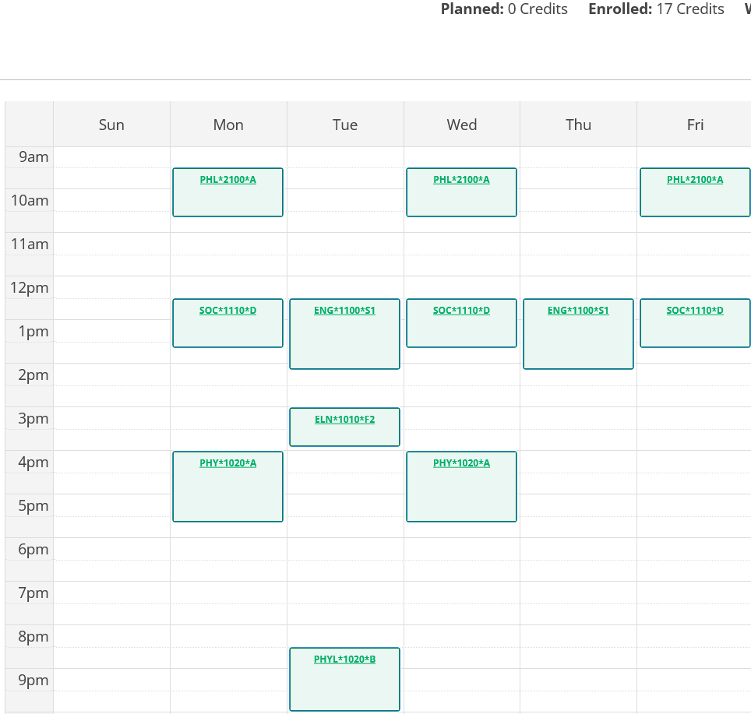
Course List of 17 semester hours:
- ELN 1010 – required
- ENG 1100 – required First-Year Foundations writing/discussion course
- PHL 2100 – Expression Non-Literature
- PHY 1020 – Astronomy lecture
- PHYL 1020 – Astronomy Lab
- SOC 1110 – Society
Note: This student is not enrolled in a major specific course but is on track to complete the English degree in four years.

English Major Example Schedule
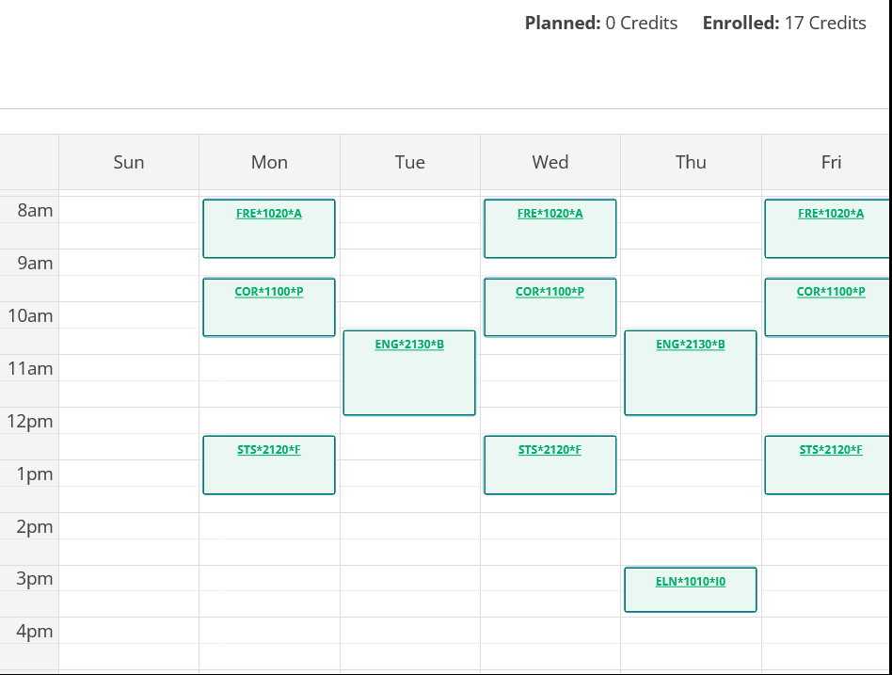
Course List of 17 semester hours:
- ELN 1010 – required
- COR 1100 – required First-Year Foundations writing/discussion course
- FRE 1020 – Civilization + World Language Proficiency Requirement
- STS 2120 – First-Year Foundations Math
- ENG 2130 – Major only; not part of Elon Core Curriculum

