First-Year Advising & Registration Guidebook

Major in Middle Grades Education
Middle Grades Education offers multiple concentrations. These are subdisciplines of the major. For Middle Grades, these options are:
- English
- Social Studies
- Mathe
- Science

Your First-Year Advising & Registration (FYAR) Guidebook will help you identify classes of interest for your first semester at Elon University. Use this with your online preorientation, Elon Bound. You will also want to spend time on the FYAR section of the Office of Academic Advising website where you will find video tutorials and frequently asked questions.

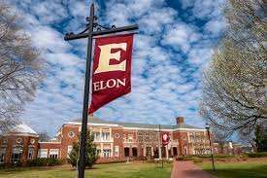
Your FYAR Guidebook provides information for recommended classes in your area of academic exploration. Read this information carefully and complete the worksheet section of the guidebook before attending your small group virtual advising meeting.

Recommended Courses: Middle Grades Education
Your first semester schedule will consist of the following:
- ELN 1010: First Year Advising Seminar (required)
- COR 1100 OR ENG 1100 (required)
Choose 1 of the following courses: | - Education (EDU) 2110: Education and Society  - Sociology (SOC) 2430: Sociology of Education
English Concentration:
No additional major specific recommendations for fall 2024
Social Studies Concentration (all count either in Society or Civilization):
- Economics (ECO) 1000: Principles of Economics
- Geography GEO) 1310: The World’s Regions
- Choose from:
  - History (HST) 1110: Making of the West to 1500; or,
  - History (HST) 1120: Search for Order in Modern Europe
- Choose from:
  - Political Science (POL) 1110: American Government; or,
  - Political Science (POL) 1610: Comparative Politics
Mathematics Concentration (options based on Math Placement):
- Statistics (STS) 1100: Intro to Statistical Reasoning
- Math (MTH) 1510: Calculus I
Science Concentration (count in Science with Lab requirement):
- Chemistry (CHM) 1110: General Chemistry I with CHML 1110 Lab
- Environmental Science (ENS) 1110: Intro to Environmental Science with Lab
All Concentrations Additional Options:
- Studies in the Arts & Sciences Course from Expression Non-Literature, Civilization
- World Language requirement course, based on World Language assessment
Your goal is to register for 16-18 semester hours for the upcoming semester, with 17 semester hours being the most common course load.
Alternate classes are critical so plan for at least 8 classes of interest that can be taken in your first semester or would be of interest for a future term.
Building Your Schedule Worksheet
Complete this worksheet to determine classes of interest for your first semester at Elon. You should have a minimum of 10 classes of interest to consider. This will best enable you to create a schedule with both class interests and times that are most effective for your learning.
- Circle/highlight the class you are pre-enrolled in. You will complete both courses, 1 in the fall and the other in the spring. | - COR 1100: The Global Experience  - ENG 1100: Writing – Argument & Inquiry
- Are you undecided on what major to pursue? Consider enrolling in Enroll in ELN 1110: Exploring Majors for 1 semester hour. | Circle level of interest:  Yes  No
- Enter your ELN 1010 course time in the box to the right. Check your schedule in OnTrack.
- How many credits do you want to take this semester? Overall, 17 credits is the most common. A minimum of 12 is needed to be full-time. First semester students enrolled in ELN 1010 can enroll in up to 19.
- My Math Placement is (check your Timeline in OnTrack):
- Do you want to take First-Year Foundations Math this semester?
- My World Language Placement is (check your Timeline in OnTrack):
- Do you want/need to take a World Language your first semester?
- What intro to major classes interest you? Be sure to list both the major and the class so you can keep track of which classes connect to which major(s). (View page 2 of this document.)
- What courses in Expression did you look up in OnTrack and find interesting?
- What courses in Civilization did you look up in OnTrack and find interesting?
- What courses in Society did you look up in OnTrack and find interesting?
- What courses in Science did you look up in OnTrack and find interesting?
- Note questions you plan to ask during your virtual advising session.

Middle Grades Education Example Schedule 1
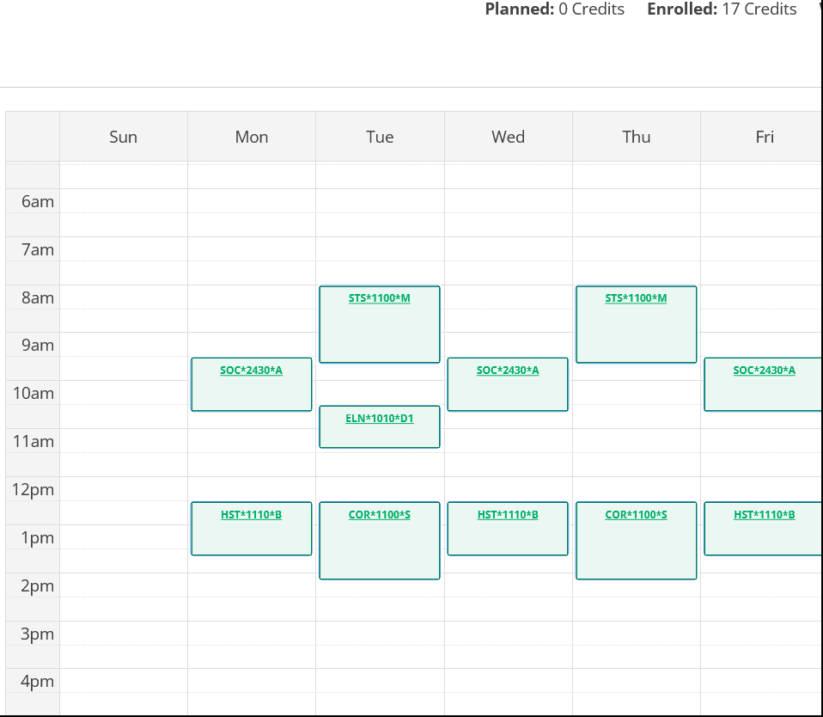
Course List of 17 semester hours:
- ELN 1010 – required
- COR 1100 – required First-Year Foundations writing/discussion course
- HST 1100 – Major + Civilization
- SOC 2430 – Major + Society
- STS 1100 – First-Year Foundations Math

Middle Grades Education Example Schedule 2
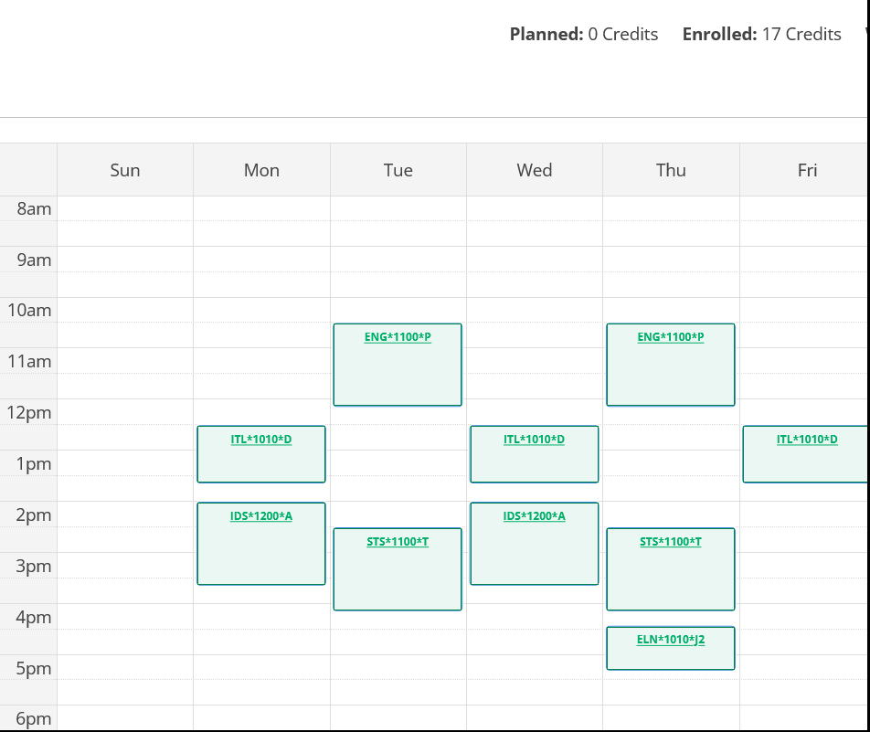
Course List of 17 semester hours:
- ELN 1010 – required
- COR 1100 – required First-Year Foundations writing/discussion course
- IDS 1200 – Expression Non-Literature
- ITL 1010 – Civilization + Course 1 or 2 towards World Language Proficiency
- STS 1100 – First-Year Foundations Math
Note: This student is pursuing a double major in Middle Grades Education and Special Education. They are on track to graduate in four years with this first semester schedule.

