First-Year Advising & Registration Guidebook

School of Health Sciences: Neuroscience


Your First-Year Advising & Registration (FYAR) Guidebook will help you identify classes of interest for your first semester at Elon University. Use this with your online preorientation, Elon Bound. You will also want to spend time on the FYAR section of the Office of Academic Advising website where you will find video tutorials and frequently asked questions.

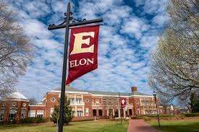
Your FYAR Guidebook provides information for recommended classes in your area of academic exploration. Read this information carefully and complete the worksheet section of the guidebook before attending your small group virtual advising meeting.

Recommended Courses: Neuroscience
Your first semester schedule will consist of the following:
- ELN 1010: First Year Advising Seminar (required)
- COR 1100 OR ENG 1100 (required)

The new Neuroscience major will include classes in categories such as scientific foundations, disciplinary neuroscience, neuroscience methods, integrative courses, and more. The official major will post in the 2025-2026 Academic Catalog.

The courses below can be considered for a potential Neuroscience major. Do not expect to take all of these in your first semester.
Neuroscience Course Options:
- Neuroscience (NEU) 1100/1700: Integrative Neuroscience
- Chemistry (CHM) 1110: General Chemistry I with concurrent enrollment in Chemistry Lab (CHML) 1110: General Chemistry Lab I
- Statistics (STS) 2120: Statistics in Application (based on math placement)
- Psychology (PSY) 1000: Intro to Psychology (common Society elective for students pursuing a health-oriented career)
Additional Options:
- Studies in the Arts & Sciences Courses under Expression, Civilization, and Society.
Important Notes:
- AP Chemistry and AP Biology of a 4 or 5 do not result in credit for either CHM/CHML 1110 or BIO 1112/1113. Students will earn LAB 1XXX credit for these courses for the Science/Analysis section of the Elon Core Curriculum.
- Neuroscience majors will take BIO 1112/1113: Intro to Cell Biology in the spring semester of their first year at Elon.
- Students who do not complete CHM 1110/CHML 1110 in their first semester may need to take summer Chemistry classes in order to complete their degree in four years.
Your goal is to register for 16-18 semester hours for the upcoming semester, with 17 semester hours being the most common course load.
Alternate classes are critical so plan for at least 8 classes of interest that can be taken in your first semester or would be of interest for a future term.

Building Your Schedule Worksheet
Complete this worksheet to determine classes of interest for your first semester at Elon. You should have a minimum of 10 classes of interest to consider. This will best enable you to create a schedule with both class interests and times that are most effective for your learning.
- Circle/highlight the class you are pre-enrolled in. You will complete both courses, 1 in the fall and the other in the spring. | - COR 1100: The Global Experience  - ENG 1100: Writing – Argument & Inquiry
- Are you undecided on what major to pursue? Consider enrolling in Enroll in ELN 1110: Exploring Majors for 1 semester hour. | Circle level of interest:  Yes  No
- Enter your ELN 1010 course time in the box to the right. Check your schedule in OnTrack.
- How many credits do you want to take this semester? Overall, 17 credits is the most common. A minimum of 12 is needed to be full-time. First semester students enrolled in ELN 1010 can enroll in up to 19.
- My Math Placement is (check your Timeline in OnTrack):
- Do you want to take First-Year Foundations Math this semester?
- My World Language Placement is (check your Timeline in OnTrack):
- Do you want/need to take a World Language your first semester?
- What intro to major classes interest you? Be sure to list both the major and the class so you can keep track of which classes connect to which major(s). (View page 2 of this document.)
- What courses in Expression did you look up in OnTrack and find interesting?
- What courses in Civilization did you look up in OnTrack and find interesting?
- What courses in Society did you look up in OnTrack and find interesting?
- What courses in Science did you look up in OnTrack and find interesting?
- Note questions you plan to ask during your virtual advising session.

Neuroscience Example Schedule 1

Neuroscience is a new major starting in fall 2025. The example schedules are potential schedules for students pursuing this major.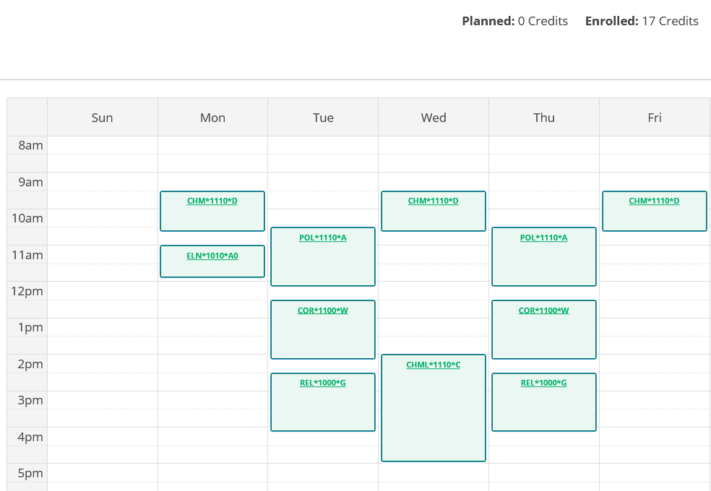
Course List of 17 semester hours:
- ELN 1010 – required
- COR 1100 – required First-Year Foundations writing/discussion course
- CHML 1110 – required for major and counts as Science/Analysis required lab in the Elon Core Curriculum
- POL 1110 – counts as a Society elective
- REL 1000 – counts as a Civilization elective

Neuroscience Example Schedule 2

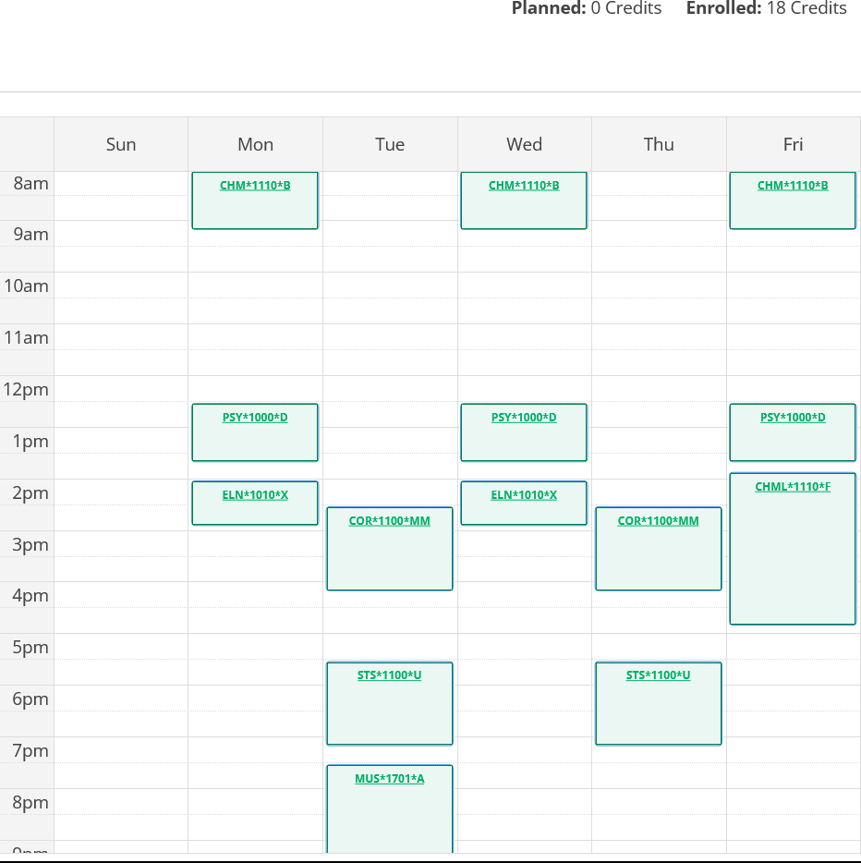
Course List of 18 semester hours:
- ELN 1010 – required
- CHM 1110 and CHML 1110 – required for major and counts as Science/Analysis required lab in the Elon Core Curriculum
- COR 1100 – required First-Year Foundations writing/discussion course
- STS 1100 – required First-Year Foundations Math based on placement result
- PSY 1000 – counts as a Society elective
- MUS 1701 (Concert Band) – 1 semester hour class that counts towards Expression

