First-Year Advising & Registration Guidebook

English and Professional Writing & Rhetoric


Your First-Year Advising & Registration (FYAR) Guidebook will help you identify classes of interest for your first semester at Elon University. Use this with your online preorientation, Elon Bound. You will also want to spend time on the FYAR section of the Office of Academic Advising website where you will find video tutorials and frequently asked questions.

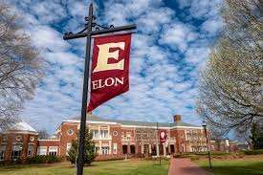
Your FYAR Guidebook provides information for recommended classes in your area of academic exploration. Read this information carefully and complete the worksheet section of the guidebook before attending your small group virtual advising meeting.

Recommended Courses: English A.B.
Your first semester schedule will consist of the following:
- ELN 1010: First Year Advising Seminar (required)
- COR 1100 OR ENG 1100 (required)
Additional Course Options Based on Major:
English, A.B.:
Concentrations: Literature, Creative Writing, Self-Designed and Teacher Licensure (English Majors)
Course Options (Expression/Literature):
- English (ENG) 2220: British Life after 1800
- English (ENG) 1710: Secrets, Spies, & Surveillance (not for Teacher Licensure)
- English (ENG) 1760: How Poetry Works (not for Teacher Licensure
- English (ENG) 2130: Intro to Creative Writing (not for Teacher Licensure)

Professional Writing and Rhetoric A.B. (all 3 count in Society + Major):
- Professional Writing and Rhetoric (PWR) 2100: Professional Writing and Technology Studio
- Professional Writing and Rhetoric (PWR) 2110: Professional Writing and Rhetoric
- Professional Writing and Rhetoric (PWR) 2130: Publishing and Editing I
Both Majors Additional Options:
- First-Year Foundations Math
- World Language Proficiency course, if necessary
- Studies in the Arts & Sciences Course from Civilization or Science

Your goal is to register for 16-18 semester hours for the upcoming semester, with 17 semester hours being the most common course load.
Alternate classes are critical so plan for at least 8 classes of interest that can be taken in your first semester or would be of interest for a future term.

Building Your Schedule Worksheet
Complete this worksheet to determine classes of interest for your first semester at Elon. You should have a minimum of 10 classes of interest to consider. This will best enable you to create a schedule with both class interests and times that are most effective for your learning.
- Circle/highlight the class you are pre-enrolled in. You will complete both courses, 1 in the fall and the other in the spring. | - COR 1100: The Global Experience  - ENG 1100: Writing – Argument & Inquiry
- Are you undecided on what major to pursue? Consider enrolling in Enroll in ELN 1110: Exploring Majors for 1 semester hour. | Circle level of interest:  Yes  No
- Enter your ELN 1010 course time in the box to the right. Check your schedule in OnTrack.
- How many credits do you want to take this semester? Overall, 17 credits is the most common. A minimum of 12 is needed to be full-time. First semester students enrolled in ELN 1010 can enroll in up to 19.
- My Math Placement is (check your Timeline in OnTrack):
- Do you want to take First-Year Foundations Math this semester?
- My World Language Placement is (check your Timeline in OnTrack):
- Do you want/need to take a World Language your first semester?
- What intro to major classes interest you? Be sure to list both the major and the class so you can keep track of which classes connect to which major(s). (View page 2 of this document.)
- What courses in Expression did you look up in OnTrack and find interesting?
- What courses in Civilization did you look up in OnTrack and find interesting?
- What courses in Society did you look up in OnTrack and find interesting?
- What courses in Science did you look up in OnTrack and find interesting?
- Note questions you plan to ask during your virtual advising session.

Professional Writing & Rhetoric Major Example Schedule 1
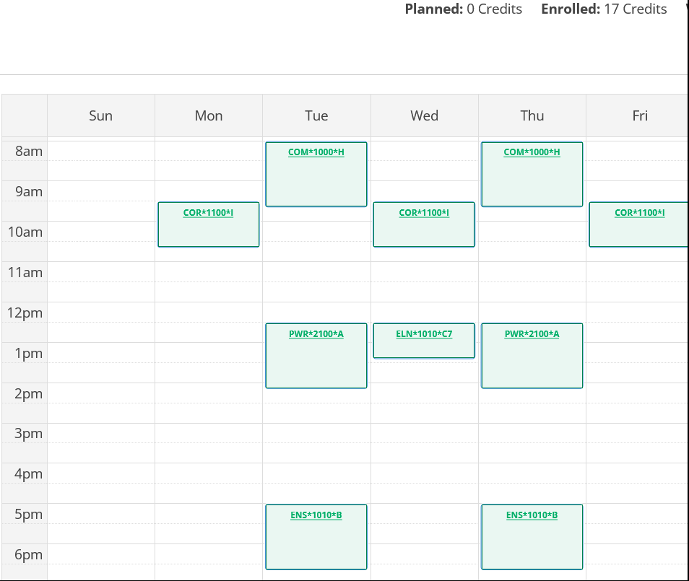
Course List of 17 semester hours:
- ELN 1010 – required
- COR 1100 – required First-Year Foundations writing/discussion course
- ENS 1010 – Science/Analysis Non-Lab
- PWR 2100 – Major + Society
- COM 1000 – Exploratory Course for Major or Minor outside of the Elon Core Curriculum

Professional Writing & Rhetoric Major Example Schedule 2
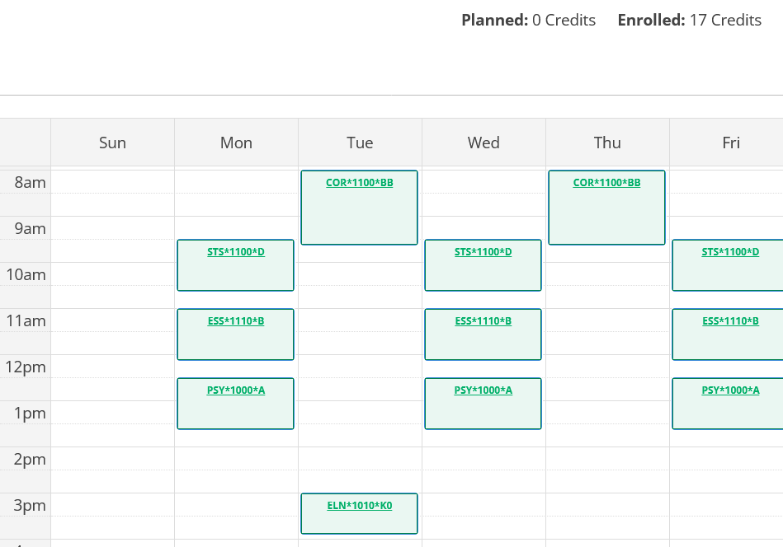
Course List of 17 semester hours:
- ELN 1010 – required
- COR 1100 – required First-Year Foundations writing/discussion course
- STS 1100 – First-Year Foundations Math
- PSY 1000 – Society
- ESS 1110 – Science/Analysis Non-Lab

