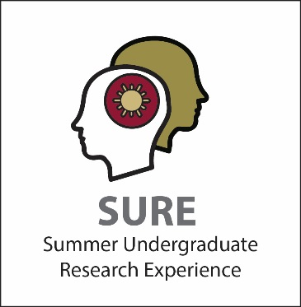
SURE Program Mentor Application Guidelines

The SURE program is one of Elon’s most intensive undergraduate research experiences. Full-time faculty are eligible to be SURE mentors. Faculty signatures on the application indicate that they endorse the student and project (i.e., that they have read the application and approve it).

Mentors are expected to:
- offer a more intensive mentoring experience than is typical during the regular semester
  - have regular and sustained interactions with their SURE students multiple times a week (typically these meetings occur in-person and face-to-face for on-campus SURE)
- generally are not away from the student for more than 14 days (for on-campus SURE)
- be available to the student researcher for the entire 8-week program period
  - be actively working with the SURE student for the majority of SURE
- attend all three SURE lunches, including the last day poster sessions (for on-campus SURE)
- spend additional time in preparation [e.g., co-reading articles that will be discussed with student] and follow-up [e.g., reviewing student drafts].

Number of students: Given the significant commitment involved in effective mentoring, mentors are limited to no more than two “load units” during the summer. That is, a faculty member may pursue up to 2 SURE students; pursue 1 SURE student and teach a summer class; etc. Mentoring more than 2 SURE students will not be supported.

Compensation: Faculty who mentor one student will receive one full stipend ($3,000). Faculty who mentor two students will receive 1.5 stipend ($4,500). Any variations thereof are scaled accordingly to a maximum of 1.5 stipend.

For more information on mentoring undergraduate research, please visit our mentor page: http://www.elon.edu/e-web/academics/undergraduate_research/mentor.xhtml

