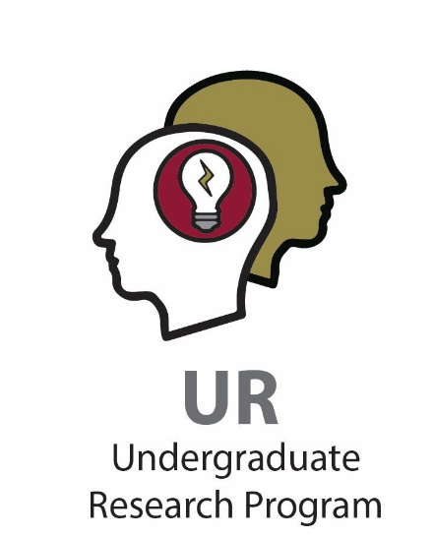
NCUR TRAVEL GRANT INFORMATION
WHAT IS NCUR?
NCUR is an annual undergraduate research conference. It is held each spring and organized by the Council on Undergraduate Research in cooperation with a host campus when it is in-person. Open to undergraduate students in all disciplines and all institutions of higher education, NCUR routinely boasts more than 4,000 presentations delivered by students from over 400 different colleges and universities. This exciting opportunity to disseminate results at a national venue and network with so many other student researchers from across the nation is truly unique.

NCUR LOCATION AND WEBSITE
The venue for NCUR changes from year to year. In 2024, NCUR will be held in Long Beach, CA April 8-10, with travel scheduled April 7-11. The official conference website is: https://www.cur.org/what/events/students/ncur/ncur_2024/
It contains important information that may be of interest to students and mentors.
POLICIES AND EXPECTATIONS
Elon commits substantial funds to support student travel to NCUR. In order to offer funding for NCUR travel to as many students as possible, the Undergraduate Research Program (URP) has established the following policies and expectations for students who apply for NCUR Travel Grants.
- The NCUR Travel Grant application is done online at the following site: https://docs.google.com/forms/d/e/1FAIpQLSfnHmCmHPaiBvEy8j4mB-4v0W20U9zvdAFlsglMDcr0hUp_RQ/viewform?usp=sf_link
- Applications for URP funds are due before the deadline to submit abstracts to NCUR! Here is the sequence of activity to follow:
  - Submit a travel grant application by November 3, 2023 at 5pm to Elon URP, including your abstract. The abstract should be reviewed and approved by the faculty mentor prior to submission to URP.
  - Get feedback on the abstract from Elon URP and approval for travel funding (by November 27, 2023)
  - Submit your final abstract to NCUR by December 8, 2023..
  - Register for the conference as a group, in a meeting hosted by Elon URP in January 2024. Please do not register by yourself!
- Students will need the following information to submit an application: University ID, mentor(s) email, title, short title (30 character max), and abstract. The abstract must follow NCUR’s formatting guidelines (see the Travel Grant application for more information). The students will also need to
confirm they have familiarized themselves with the policies, expectations and deadlines outlined in this document.
- NCUR Travel Grants typically cover all of the following expenses: airfare, hotel, registration (which includes breakfast and lunch during the conference), and group ground transportation between
Elon, airports, hotels, and the NCUR host campus. All other expenses are the responsibility of the student.
- URP requires a $100 deposit. The deposit will be refunded if (a) the student’s proposal is not accepted by the NCUR reviewing committees, or (2) they withdraw from presenting prior to January 30. Students will not be prevented from attending NCUR if they are unable to contribute $100. URP will award a small number of need-based mini-grants to cover the deposit for those who require it.
- Elon URP leadership will travel with students to NCUR as a group. Individual travel grants to NCUR will not be awarded.
- Students should plan to leave Elon’s campus on Sunday April 7. We will arrive home on Thursday April 12. Students must verify they have no known conflicts with the NCUR travel dates.
- Only one student per presentation will be supported.
- URP may not be able to fund travel to more than one conference for a given student. Therefore,
students should consult with their mentors to determine which venue is the most appropriate dissemination outlet. Students are expected to attend the NCUR Registration Meeting, in January 2024 (see the timeline below). At this meeting, we will register for the conference together and go over basic travel / conference logistics.
TIMELINE AND DEADLINES
1. Before 5pm on November 3, 2023: Complete Elon NCUR Travel Grant application and submit it online, including the abstract.
2. Before 5pm on November 27, 2023: Students and mentors are notified of funding approval.
3. By December 8, 2023: After receiving approval from URP, students and mentors submit abstracts to NCUR at the NCUR website. Information about this process will be sent by URP by November 27, 2023
WHEN SUBMITTING YOUR ABSTRACT
After you enter your own information, the NCUR website may ask you to enter information for the Undergraduate Research Office Coordinator. Please fill this out as indicated below:
Coordinator First Name: CJ
Coordinator Last Name: Fleming
Coordinator Institution State / Country: North Carolina
Coordinator Institution: Elon University
Coordinator Email: cfleming6@elon.edu
Coordinator Title: Associate Director, Undergraduate Research Program Coordinator Phone: 336-278-5763.
FURTHER INFORMATION
Students and mentors can direct all questions to Dr. CJ Fleming at cfleming6@elon.edu

