Elon Academy Saturday Program
All Scholars, Pi and Omicron Families
February 19, 2022
9:00 am – 12:30 pm
*Please arrive by 8:50 to check-in
Next Saturday Program
March 19, 2022 (All Scholars and Xi Families)

To hold in-person programming, we must follow University rules for masks and check-in procedures. Elon University currently requires masks in all buildings and outside when social distancing cannot be maintained. Upon check-in, everyone will respond to questions about symptoms associated with COVID-19 (e.g. cough, loss of taste or smell) and exposure to the infection. Given our enhanced check-in procedures, we ask that you make every effort to be at the check-in table by 8:50am so we can begin on time and keep to our schedule.
Check-in will be in KOBC (Park in the Colonnades lot behind KOBC- reminder we cannot park in the admissions lot, or The Inn at Elon-towing/ticketing enforced). Scholars and families will then go to KOBC, room 101.
If, prior to programming, a scholar feels sick or is aware of exposure to COVID-19 they should NOT attend the program. We ask scholars to communicate their absence to Mrs. Teeters at elonacademy@elon.edu or call 336-278-6109 and follow-up with their college planning faculty to see what they will miss. If you have concerns about health and safety, please contact Mrs. Teeters. As a reminder, the expectation is that all scholars will attend every Saturday program. There is no option to attend virtually. Excused absences are given only for sickness, family emergency, exposure to COVID-19, or death in the family. School related (e.g. marching band) events, sports conflicts, and work are not excused absences. Missing a Saturday program will put a scholar behind in important college planning work that they are unable to “make up.”

Scholar Announcements

Please send your test scores to Mr. Pickett at jpickett@elon.edu. PACT scores are out now, and SAT scores should be out soon.

CAT Mentor meetings have begun for the spring semester. Scholars are required to meet with their CAT mentor three times per semester (February, March, and April).

Spring SAT Prep: All scholars who have chosen to participate in the spring semester SAT Prep should plan to stay following the February Saturday Program to get set up on the SAT Prep Program and to take a practice test. If scholars have a graphing calculator, they are encouraged to bring it. Lunch will be included, and the prep will conclude around 4/4:30pm. Scholars will then work on SAT Prep individually and virtually throughout the spring semester with guidance and assignments personalized to their SAT prep needs. Scholars doing Spring SAT Prep will be ready to take the SAT as early as March. If families or scholars have any questions about SAT Prep they can reach out to Mr. Pickett.

There are only a few spots left for the Fall 2022 SAT Prep. If you are interested in this, please email Mr. Pickett ASAP.

Fee Waivers: All juniors and seniors are eligible for SAT/ACT fee waivers. You are eligible for two fee waivers which allow you to take the SAT twice at no cost. Scholars will take the ACT once for free through their school, but Elon Academy recommends scholars consider taking it a 2nd time. To obtain your fee waiver, you must reach out to your school counselor. As a reminder, Elon Academy does not have fee waivers for the SAT/ACT. The only place you can get these is from your school counselor’s office.

Please continue to send proof of COVID-19 vaccination to Mrs. Teeters at elonacademy@elon.edu.

It is important that you provide your own transportation whenever possible. We do not have the staff to pick up large numbers of students. If you need a ride, call the Elon Academy office at 336-278-6109 by the WEDNESDAY at 5pm before EVERY Saturday program.

Upcoming Events
February 11, 2022- Registration for the March 12th SAT
Elon Academy Saturday Programs: February 19th, March 19th, and April 2nd

Family Corner

February 19th, 2022
Omicron and Pi Families: Please see the attached document for important information on items to bring to the Saturday Program to complete a financial aid estimator tool.

Pi Families: We will be walking to the Elon University library for a tour and the opportunity to receive a free University library card. Comfortable shoes and coats are encouraged!

CAT Mentoring begins for the spring semester in February. Scholars are expected to meet with their mentor three times (February, March, and April). Some scholars will receive a new CAT Mentor for the spring semester. Family members are welcome to join one meeting each semester. Any questions about CAT Mentoring should be directed to Mr. Pickett.

Summer dates are on the website! We are planning a 3-week residential program from June 12-July 1, 2022. Similar to Alamance-Burlington Schools, we highly encourage scholars to receive a COVID-19 vaccine and booster. Scholars are expected to attend the entire three weeks. Please do not plan vacations, routine doctor’s appointments, senior pictures, or driver’s education during these dates. Scholars should communicate these dates ASAP to sports coaches and/or employers.

Our next Family Saturday Programs are:
- Sophomore (Pi) and Junior (Omicron) families- April 2nd
- Senior (Xi) families- March 19th
Some fun (and FREE with your Phoenix Card) on-campus events:
Elon Women’s Basketball vs. Northeastern: Sunday, February 20 at 1 pm in Schar Center.
Elon University’s Spring Musical: Into the Woods February 11-13. For more information and reservations: www.elon.universitytickets.com

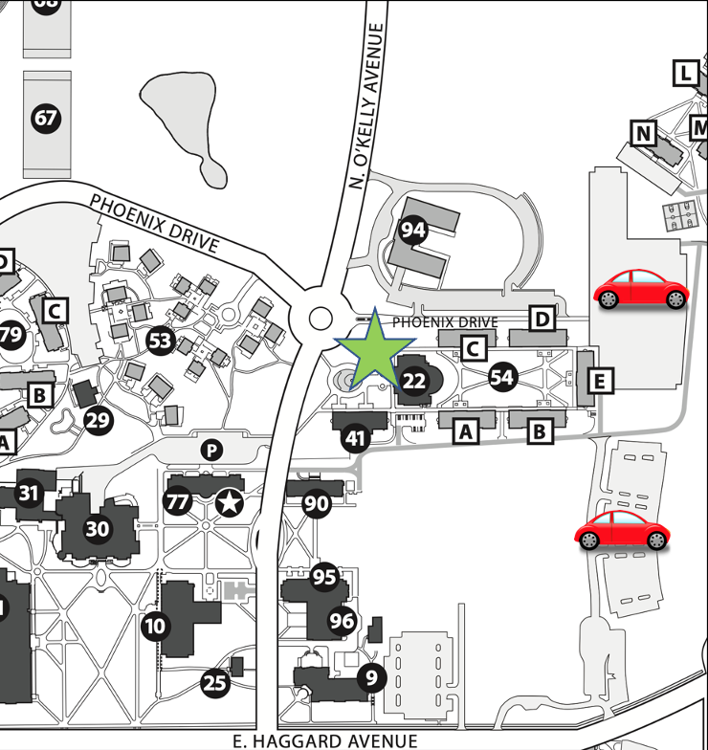
Koury Business Center and Sankey Hall Directions
Take Highway 70 West/South Church Street to Williamson Avenue. Turn right on Williamson. Follow this road for 1.7 miles. You will cross railroad tracks as you enter the campus area. Continue through the stoplight. Turn right on Haggard Avenue. Turn left on O’Kelly Avenue. Koury Business Center will be on your right.

