Elon Academy Saturday Program
All Scholars, Xi Families
March 19, 2022
9:00 am – 12:30 pm
*Please arrive by 8:50 to check-in
Next Saturday Program
April 2, 2022 (All Scholars and Pi/Omicron Families)

On Monday, March 14, Elon will shift to an indoor mask optional policy for all campus spaces. Elon endorses the rights of everyone to make their own personal choices about wearing masks.
Upon check-in, everyone will respond to questions about symptoms associated with COVID-19 (e.g. cough, loss of taste or smell) and exposure to the infection. Given our enhanced check-in procedures, we ask that you make every effort to be at the check-in table by 8:50am so we can begin on time and keep to our schedule.
Check-in will be in KOBC (Park in the Colonnades lot behind KOBC- reminder we cannot park in the admissions lot, or The Inn at Elon-towing/ticketing enforced). Scholars and families will then go to KOBC, room 101.
If, prior to programming, a scholar feels sick or is aware of exposure to COVID-19 they should NOT attend the program. We ask scholars to communicate their absence to Mrs. Teeters at elonacademy@elon.edu or call 336-278-6109 and follow-up with their college planning faculty to see what they will miss. If you have concerns about health and safety, please contact Mrs. Teeters. As a reminder, the expectation is that all scholars will attend every Saturday program. There is no option to attend virtually. Excused absences are given only for sickness, family emergency, exposure to COVID-19, or death in the family. School related (e.g. marching band) events, sports conflicts, and work are not excused absences. Missing a Saturday program will put a scholar behind in important college planning work that they are unable to “make up.”

Scholar Announcements

Please send your test scores to Mr. Pickett at jpickett@elon.edu. PACT scores are out now, and SAT scores should be out soon.

CAT Mentor meetings have begun for the spring semester. Scholars are required to meet with their CAT mentor three times per semester (February, March, and April).

Spring SAT Prep: Scholars should work on SAT Prep individually and virtually throughout the spring semester with guidance and assignments personalized to their SAT prep needs. Scholars doing Spring SAT Prep will be ready to take the SAT as early as March. If families or scholars have any questions about SAT Prep they can reach out to Mr. Pickett.

There are only a few spots left for the Fall 2022 SAT Prep. If you are interested in this, please email Mr. Pickett ASAP.

Fee Waivers: All juniors and seniors are eligible for SAT/ACT fee waivers. You are eligible for two fee waivers which allow you to take the SAT twice at no cost. Scholars will take the ACT once for free through their school, but Elon Academy recommends scholars consider taking it a 2nd time. To obtain your fee waiver, you must reach out to your school counselor. As a reminder, Elon Academy does not have fee waivers for the SAT/ACT. The only place you can get these is from your school counselor’s office.

Please continue to send a copy of your COVID-19 vaccination card to Mrs. Teeters at elonacademy@elon.edu.

It is important that you provide your own transportation whenever possible. We do not have the staff to pick up large numbers of students. If you need a ride, call the Elon Academy office at 336-278-6109 by the WEDNESDAY at 5pm before EVERY Saturday program.

Upcoming Events
April 8th Registration Deadline for May 7th SAT
Elon Academy Saturday Programs: March 19th, and April 2nd

Family Corner

The 2022 Summer Program is a 3-week residential program from June 12-July 1, 2022. Scholars are expected to attend the entire three weeks. Please do not plan vacations, routine doctor’s appointments, senior pictures, or driver’s education during these dates. Scholars should communicate these dates ASAP to sports coaches and/or employers.

Pi and Omicron Families: We will talk more about the summer program and hand out summer-related paperwork at the April 2nd Saturday program. Additionally, we hold a family meeting on move-in day (June 12th) to provide additional information and answer questions.

Summer Program Vaccine Requirement: Scholars must be fully vaccinated before our summer program, which is defined as a two-shot vaccine and a booster shot (if eligible). If scholars require an exemption for medical or religious reasons, please email the Elon Academy office at elonacademy@elon.edu. Either an exemption form (completed by a guardian) or a copy of your vaccine card must be submitted to the EA office (via the email address above) by May 13th. Please direct any questions to Mrs. Denise Teeters at 336-278-6109. Thank you for your cooperation in helping to keep all our scholars, faculty, and staff safe on campus this summer!

Some fun (and FREE with your Phoenix Card) on-campus events:

Leland Melvin, “Chasing Space: An Astronaut’s Story of Grit, Grace and Second Chances”: Thursday, March 31st at 7 pm in Alumni Gym, Koury Athletic Center.
Elon Softball vs. UNCG: Saturday, March 19th at 1 and 3 pm. Hunt Softball Park (536 N. Williamson Ave. Elon).

Turner Theatre Movie Schedule:

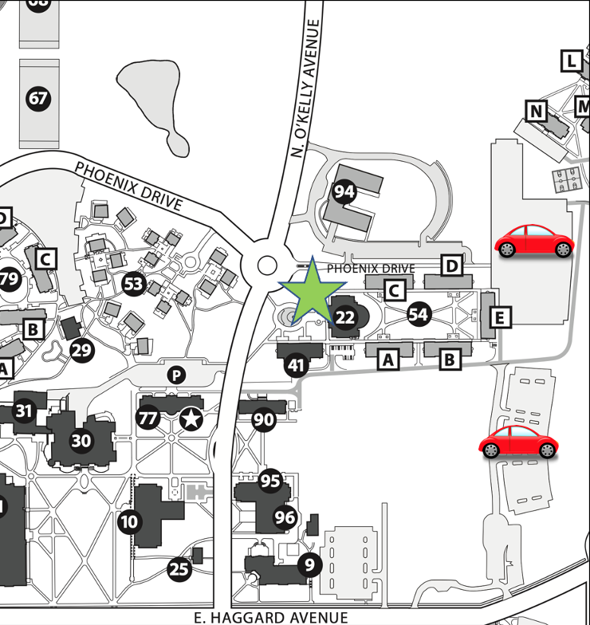
Koury Business Center and Sankey Hall Directions
Take Highway 70 West/South Church Street to Williamson Avenue. Turn right on Williamson. Follow this road for 1.7 miles. You will cross railroad tracks as you enter the campus area. Continue through the stoplight. Turn right on Haggard Avenue. Turn left on O’Kelly Avenue. Koury Business Center will be on your right.

