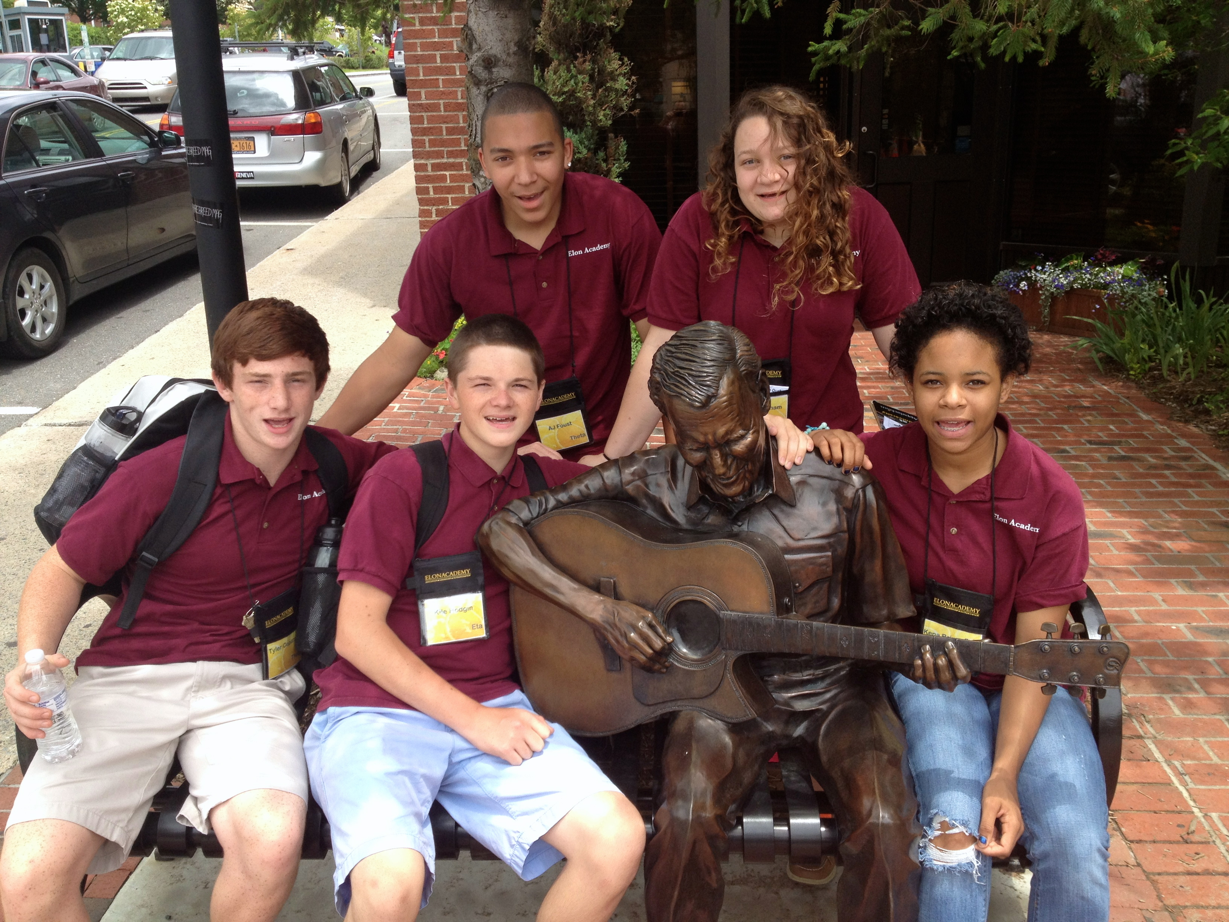
Would you be interested in providing
academic support to highly motivated
local high school students?

If so, THE ELON ACADEMY wants you!

What is the Elon Academy?
The Elon Academy is a seven-year college access and success program for academically promising high school students in the Alamance-Burlington School System who have a financial need or no family history of college. The year-round program combines three intensive four-week residential experiences at Elon University in the summers prior to the 10th, 11th, and 12th grades, with a variety of academic/enrichment activities during the school year. The Elon Academy continues to provide support to scholars while in college.

What is the goal of the Elon Academy?
Our goal is to engage Elon Academy scholars in challenging curricular, co-curricular, and cultural experiences to ensure that they get the essential resources that they need to lead productive, fulfilling lives. This includes the skills and dispositions that will position them to succeed in institutions of higher education and to become active members of and leaders in their communities and beyond.

What is the role of an Academic Coach?
Coaches tutor and generally support Elon Academy scholars in their regular high school coursework. We provide coaches on an as-needed basis when a scholar indicates a need for help and a coaching schedule can be arranged. Occasionally, an Academic Coach will be required for scholars who may be struggling academically.

Coaches may work with only one scholar or with several scholars, depending on need and availability. Session dates and times are worked out between individual scholars and their coach. Regularity and consistency are essential to the effectiveness of this program. Academic Coaches are asked to gather information from the scholars prior to coaching sessions, use this information to design the session, assign tasks to the scholars for the time in between sessions, and record minutes and reflections of each session via an online reporting system.

Academic Coaches will be required to complete a training session before beginning work to become familiar with the program expectations and must be cleared through a background screening process. The position includes tutoring, preparing for tutoring sessions, and reporting online the results of sessions. All of this is included in the paid hours.

What are the benefits of being an Academic Coach?
As a coach you will:
- build your leadership skills and serve as a role model to high school students
- enjoy working with academically-promising and motivated students
- earn $10/hour (travel time is unpaid)

Who would be an ideal candidate to be an Academic Coach?
An individual who:
- is academically skilled in a core subject (math, science, social sciences, foreign language, and English/writing)
- is a current Elon University student
- is both positive and patient
- is available during the Fall and Spring Semester (some flexibility allowed; Winter term is a plus!)
- can provide his or her own transportation (however; transportation is not required)
- can stay up-to-date with brief online reports on coaching activities

I am interested in applying for a position with the Elon Academy. What should I do?
Required materials should be submitted for review immediately to Mr. John Pickett in The Center for Access and Success (located on the 3rd floor of Mooney Building) or Campus Box 2108. Please submit the following materials:
- The attached Application with three references (name/contact info only)
- A Resume
- An Unofficial Transcript (if you are a freshmen applying your first semester please provide an academic transcript from your high school)

If you have any additional questions, please feel free to contact:
Mr. John Pickett
Associate Director, Elon Academy
336.392.7728
jpickett@elon.edu

AcademiC Coach APPLICATION

First Name: __________________________ Last Name:______________________________ Date: _______________

Mailing Address: _____________________________________________________Phone: _______________________

Email: ___________________________ Major: ___________________________ Minor: _______________________

7-digit Student ID Number:_____________

Status at Elon University:
Freshman Sophomore Junior Senior Other (explain) ____________________________

Do you speak Spanish?
Yes No If so, at what level?Beginner Intermediate Advanced

Coaching Areas:
In which subjects/levels/courses would you feel comfortable working with high school students? Please specify any high school subjects you are comfortable with as well as courses you have taken in these subjects at the high school and college level.

Writing (specify which levels)  ___________________________________  ___________________________________  ___________________________________ | Math (specify which courses)  ___________________________________  ___________________________________  ___________________________________
Social Studies (specify which courses)  ___________________________________  ___________________________________  ___________________________________ | English (specify which levels)  ___________________________________  ___________________________________  ___________________________________
Foreign Language (specify which languages)  ___________________________________  ___________________________________  ___________________________________ | Science (specify which courses)  ___________________________________  ___________________________________  ___________________________________
Other Subjects (specify what levels)
Accounting _______________________ Drama ___________________________
Applied Health ____________________ Psychology _______________________
Criminal Justice ____________________ SAT/ACT Prep ___________________
Other ___________________________________________________________________

Which semesters do you expect to be available to coach? Fall Winter Spring

Are you an Elon Teaching Fellow interested in volunteering your time for the first 10 hours of coaching? Yes No

Have you had “Protections of Minors” Training from Elon University? Yes No

Prior to completing this application, have you submitted a background check through Elon University and have you successfully been cleared via this process? Yes No

Prior to completing this application, have you submitted a background check to the Alamance-Burlington School System and have you successfully been cleared via this process? Yes No

Please provide three references who can speak to your abilities for this position:

Name: _____________________________________ Relationship: ____________________________________
E-mail: ____________________________________ Phone/Other Contact: _____________________________

Name: _____________________________________ Relationship: ____________________________________
E-mail: ____________________________________ Phone/Other Contact: _____________________________

Name: _____________________________________ Relationship: ____________________________________
E-mail: ____________________________________ Phone/Other Contact: _____________________________

Please provide any other information that might be useful to us:

