

INSTITUTIONAL REVIEW BOARD

IRB Protocol Submission Instructions for Faculty and Staff

Accessing the IRB Mentor System to Establish an Account

- Click here to access the IRB Mentor system.

- Log in using your Elon username and password.

Left Navigation Menu Overview

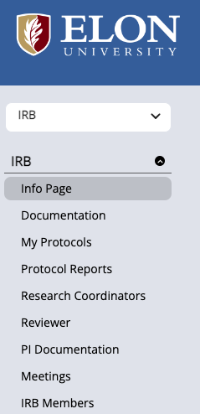 | - On the PI Documentation page, you must upload your certificate confirming completion of CITI Program training. This documentation is required before the committee will review your submission. At Elon, CITI Program certification must be renewed every four years.
 | - Upon logging in to the IRB Mentor system, you will first be directed to the Info Page, which provides general instructions for submitting a new protocol.
 | - Under Documentation, you will find essential resources to help you prepare for the IRB process including the IRB Application Form, Amendment and Adverse Event Report Forms, and sample IRB protocols.
 | - Use the My Protocols page to submit and manage your protocol submissions.

Submitting a New IRB Protocol

- Download the IRB Application Form:
Go to the Documentation section and download the IRB Application form. Complete the form by answering all questions to describe the relevant aspects of your research proposal.

- Prepare Your File:
Combine your entire application (including any supporting materials) into a single PDF document. Only one file can be uploaded during the initial submission. Note: After the initial submission, additional documents can be uploaded by going to: My Protocols > select your protocol > Files > Upload.

- Start a New Submission:
Click My Protocols in the left-hand menu, then select the Create New Protocol button at the top left of the page.

- Complete the Online Form:
Begin by completing the Pre-Protocol Diagnostic Survey, which helps determine the appropriate review category. Then, fill in all required fields and select the options that best apply to your study. Note: The IRB makes the final determination on the review category (Exempt, Expedited, or Full Board), but it is helpful for the investigator to make an initial selection.

- Upload Your Protocol:
At the bottom of the form, click the Choose File button under Upload Protocol Description and select your combined PDF document.

- Submit Your Protocol:
After uploading your file, click the Save button at the bottom of the form. Then, click the Submit Protocol for Review button to finalize your submission.

- Next Steps:
Once submitted, the IRB is automatically notified. You will receive a formal response from the IRB Chair after the review is complete.

Submitting a Revised Protocol

- Prepare Your File:
Highlight all additions and deletions in your revised protocol. This helps IRB reviewers easily identify what has changed.

- Start the Resubmission:
Click My Protocols in the left-hand menu, then select the title of the protocol you want to revise from your list.

- Upload Your Revised Protocol:
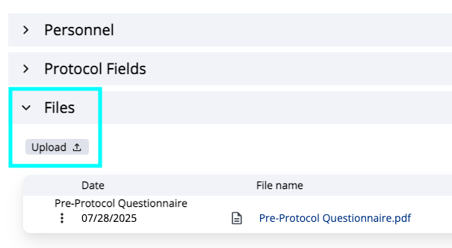 | Once the View Protocol screen opens, click horizontal chevron (>) on the Files tab in the gray header bar. Then, click the Upload button.

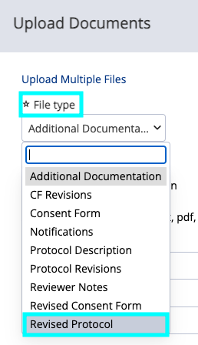 | Select the appropriate File Type for each file you upload. Click Choose File to locate your revised protocol on your computer, then click Save at the bottom to complete the upload.

- Submit Your Revised Protocol:
After uploading the file, click the Submit Protocol for Review button. Note: Be sure the revised protocol is uploaded before clicking Submit.

- Next Steps:
Once submitted, the IRB is automatically notified that your revised materials have been received. You will receive a formal response from the IRB Chair after the review is complete.

Submitting an Amendment

- Prepare Your File:
Go to the Documentation section and download the IRB Amendment Form. Complete the form by answering all relevant questions to describe your proposed modifications.
- Start an Amendment Submission:
Click My Protocols in the left-hand menu, then select the title of the protocol you want to modify from your list.

- Upload Your Amendment Form:
Once the View Protocol screen opens, scroll to the bottom of the page. Click the Amendments tab, then click the New Amendment button.
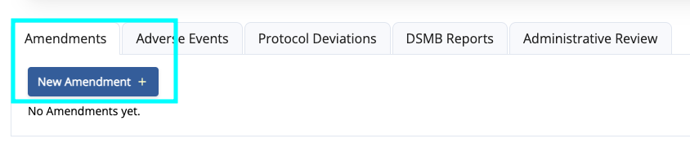
- Submit Your Amendment Form:
After clicking the New Amendment, the Create Amendment button will appear. Click Create Amendment to generate a new amendment record.

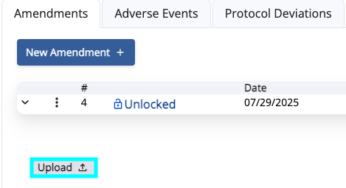 | Once the record is created, click the Upload button to upload your completed amendment form.

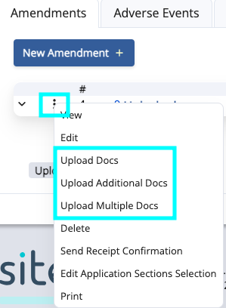 | Additional upload options (e.g., Upload Additional Docs, Upload Multiple Docs) can be accessed via the Context Menu (three vertical dots next to the chevron).

Click Choose File to locate your amendment form on your computer, then click Save at the bottom to complete the upload.

After uploading the file, click the Submit button to finalize the amendment submission.

- Next Steps:
Once submitted, the IRB is automatically notified that your amendment materials have been received. You will receive a formal response from the IRB Chair after the review is complete.

