Part I: Preliminary Information
Title: Designing a Smart Mobility Product for an Elderly Population
Abstract:
Industrial designers solve problems by creating or redesigning products to optimize functionality, enhance aesthetic appeal, and maximize ease-of-use. As “Baby Boomers” age a larger portion of the population than ever before will experience age-related disabilities and will look for innovative products to solve their mobility difficulties. Mobility is vital to physical and emotional well-being, as decreased autonomy leads to dependency and a sense of isolation. Knowledge regarding product design for those with mobility impairments, specifically the elderly, is becoming increasingly important as our population ages, yet current user-centered research in the area is lacking. This project will utilize a previously published user-centered design model to attempt to design a smart mobility product for the elderly. Using the iterative design process a versatile, functional, and aesthetically pleasing mobility device will be brought from the concept stage through the manufacturing process.
Personal Statement:
When I was younger I loved building and designing gadgets and contraptions. I also always wanted to solve problems I noticed in products. I thought that my love of design and my love of solving problems were completely separate from each other, but my curiosity gelled into focus when I was given a simple assignment: “Make a paper airplane.” That was all: no questions allowed, no information about materials, no template. Twelve eager, albeit perplexed teenagers set to work on our task. After a few rounds of discussing, designing, and testing, our paper airplanes turned into Frisbees, balls, and parachutes as we identified each design’s strengths and weaknesses, and questioned the objectives of the assignment at hand. Was the airplane supposed to go as far as possible? Or was it supposed to make loops in the air as it flew? What made it a paper airplane?
That was the first of many eye-opening experiences I had in the 2011 Summer@Brown program. For three weeks, our class made prototypes, used design software, collaborated with college students, and worked in a warehouse to build functional furniture. The course, “Building a Better Mousetrap,” focused on industrial design, specifically on the iterative design process, in which a product is repetitively tested and redesigned until it performs its necessary function, yet is still aesthetically appealing to the user. This experience marked the beginning of my interest in industrial design.
Soon after, my mother introduced me to her friend, a professor of industrial design in Philadelphia. As Mr. Rozier explained his work, his research, and what his students do, I became even more interested. I wanted to know all the whys and hows of product design: ergonomics, models and rendering, product placement, and consumer desires. I began looking at products more critically, asking myself questions about why the designer made one choice rather than another, or why a certain element was or was not included in the product. What makes a product “better” than one that came before it? As I complete my Independent Major in Industrial Design Studies, pursue a Master’s Degree in Industrial Design, and work to design functional, aesthetically pleasing products, I will constantly be looking for answers to those questions.
Every population has needs to be fulfilled or problems that beg for solutions in the form of new or upgraded products. An industrial designer identifies the problem or need and designs a product that fits that function, using the iterative design process until the product’s ideal form is reached. Industrial designers ensure that every product fits the needs of the population for which it is designed, while also ensuring that the product has aesthetic appeal. For example, office chairs, dining chairs, and airplane seats are designed for different populations and purposes. The discomfort that office workers experience after hours of sedentary work led to the demand for attractive, yet ergonomically friendly office chairs. Industrial designers “built a better mousetrap,” by designing chairs for this purpose.
I find that I am drawn to helping very specific populations – children and people with disabilities. Industrial design allows me to help others while simultaneously pursuing my interests in problem solving and design. The Lumen Prize will enable me to collaborate with specialists and designers as I broaden my understanding of designing for a specific population. I will develop an understanding of the population’s needs and abilities, while also deepening my understanding of design trends. I will be able to pursue research for my Honors Thesis that goes beyond what would otherwise be possible, and will be afforded opportunities to grow as a problem solver and designer.

Part II: Project Description
Focus:
In 2009, 737 million people worldwide were older than 60. The Organization for Economic Co-Operation and Development (OECD) projects that by 2030, 35% of the worldwide population in participating countries will be over 65, and by 2050 those aged 60 or older will reach 2 billion (1, 2). In 2000, 10% of adults in their fifties had “serious mobility impairment” and 50% of adults in their eighties experienced similar difficulties (3). The rapid aging of the world’s population has implications for society as a whole, including increased spending on healthcare, large-scale redemption of pensions, and a rising number of age-related disabilities.
Increased disability is associated with decreased autonomy, leading to dependency on able-bodied members of society (4). Dependency is often stigmatized, resulting in the elderly becoming isolated. Restoration of mobility provides some independence otherwise lost to disability. Whether we define “being mobile” as embarking on transcontinental travel or taking a walk, it is vital to well-being. Greater mobility is associated with greater social interaction, lower rates of depression, and better overall physical health (1). The mobility product, proposed herein, will focus on short-distance/high-frequency movements of greatest concern to the elderly, such as walking around the house, the neighborhood, or a store (3).
There is a clear lack of products and services ideally designed for the specific needs of our aging population (5). Existing products aiding mobility such as walkers, wheelchairs, and stair-lifts are far from perfect. Many mobility aid devices are costly and do not serve all the user’s needs (6). For example, rolling walkers are most efficient when the user is on flat ground. On uneven surfaces the user may need a pick-up walker or a cane to move more easily. Furthermore, some mobility devices pose safety concerns. One study found that when using a pick-up walker, reaction time is delayed as compared to when using no device at all or when using a rolling walker. The longer it takes between a disturbance in balance and shifting weight or posture to regain balance, the greater the risk of injury (7). Canes also pose potential problems including entanglement with lower limbs, inability to pick up the cane if it is too heavy, and the possibility of having the cane tripped over or stepped on in crowds. Additionally – and counter-intuitively – while using a cane the user’s body must counteract the movement and inertia of picking up and moving the cane by altering posture on the opposite side of the body, creating a greater imbalance than that which may exist from the disability itself (6, 7).
Many currently available mobility products appear to be medical devices, making them less appealing to the user. While a product may be fully functional, its aesthetic appeal is vital in communicating information about the product to its user (8). The aesthetic elements of a product’s design influence its desirability, an important consideration regarding commercial implications. Desire to use or to interact with a product is known as “approach behavior” and lack thereof is known as “avoidance behavior.” Consumers displaying approach behaviors spend more time using a product and exploring its capabilities. Consumers displaying avoidance behavior shy away from continued use of the product (9). Elements such as color, texture, and novel gadgets can give products an air of boldness, strength, or even give the illusion that the product is of a higher quality than it actually is. Apple products convey ease of use, while the 1994 Dodge Ram pick-up truck’s front was reminiscent of the front of an 18-wheeler to communicate strength and power (9). Elements that elicit confidence, pride, excitement, freedom, and security have a positive outcome on users’ degree of satisfaction (10). Product design also includes ease-of-use elements within the structural design and choice of materials. Is the product intuitive? Is it comfortable? Ergonomic demands influence weight, texture, and shape of a product, making it imperative that the designer seamlessly merges the consumers’ ergonomic needs with aesthetic design elements (8, 10). Designs that meet ergonomic, aesthetic, and structural needs improve the user’s quality of life by allowing greater independence, usability, attractiveness, and safety (11).
The focus of this project is to create an attractive, user-friendly, and affordable product for the elderly that aids mobility and involves a smart element to monitor the user or his environment. Product research and development will be conducted using the Usability, Safety, and Attractiveness Participatory (USAP) design model (Figure 1) and design matrices (Figures 2 and 3). The matrices combine user input and professional input to determine what needs exist and how to best meet one or more of these through product design or redesign (12). The product will be brought through all stages of the design process (sketching, rendering, modeling, prototyping, producing) as detailed in my timeline.

Proposed Experiences:
This summer (2015) I will have an internship focused on product design. I will learn more about modeling, brainstorming as a team, and creating sketches and products from start to finish. In the fall of 2015 I will be in Denmark at the Danish Institute for Study Abroad. I selected this program for the formal design experience I will gain while studying there through courses such as “Innovation Through Design Thinking” and “Danish Design.” While abroad I will continue my literature review on designing for an elderly population, submit my research to the IRB, propose my Honors thesis, and complete my application to Elon’s Summer Undergraduate Research Experience (SURE). I will communicate with Dr. Charity Johansson, a geriatric specialist from Elon’s Physical Therapy school, to learn the basics of conducting a product-centered discussion, specifically with the elderly, and to get mentorship regarding geriatric research.
Dr. Johansson is involved with the Twin Lakes Retirement Community in Burlington, where I will begin data collection and analysis when I return from Denmark. The winter and spring of 2016 will be dedicated to creating the first and second round designs for my product and performing data analysis of the first and second round group discussions using the design matrix (Figure 2 and Figure 3). The USAP design model’s three rounds (Figure 1) are designed to allow the users to give input regarding the product’s design. During these sessions, senior citizens and I will discuss their concerns regarding mobility products and sketch their ideas, so I gain a better understanding of their needs. In the spring of 2016 I will be enrolled in Fundamentals of Design and Human Computer Interaction to further my understanding of design principles and of how users interact with smart technology.
During the summer of 2016, I will stay on campus with the SURE program to make full-size and scale models of my product using Foam-Core and the 3D printers already available on campus. I will also return to Twin Lakes where I conducted the design group sessions to test the models that I design. In the fall of 2016, I will program the smart element of my product and will be taking Computer Science II to strengthen my programming abilities. The programing-based component of the product will be determined simultaneously with product’s design during the first and second round groups. Examples may include biometric sensors to inform the practitioner of the user’s medical state, accelerometers to indicate when the mobility device is not balanced correctly, or sensors to alert the user of obstacles that he or she may not be aware of. Dr. Joel Hollingsworth from Elon’s Computer Science department will be assisting me in this process.
Additionally, during the summer and fall of 2016, I will collaborate with Dr. Glenn Walters at the UNC-CH Design Lab to manufacture the product I design. The spring of 2017 will be dedicated to finalizing all the components of my written report, putting finishing touches on my final product’s design and functionality, and preparing for my thesis defense. During the spring of my 2017, I expect to present my design at the American Geriatrics Society Annual Scientific Meeting and the International Conference on Design Principles and Practices. I will submit my research for publication, to a journal listed within The Design Collection and/or the Journal of American Geriatrics Society, such as “Design Principles and Practices: An International Journal” or “The Journal of The American Geriatrics Society.” I will also present my product via poster at SURF and the National Conferences on Undergraduate Research (NCUR), and will defend my Honors thesis.

Proposed Products:
The two main outputs of my project will be a smart mobility product for the elderly and a scholarly report detailing my research and design processes. Both elements of my project will contribute to my Honors thesis. I will present a poster of my final design and research at the Student Undergraduate Research Forum in 2017. I will apply to NCUR and exhibit my final design and research at two national conferences, one geriatric-based and one design-based – ideally The American Geriatrics Society Annual Scientific Meeting and the International Conference on Design Principals and Practices – in the spring of 2017, and have my research published in the corresponding peer-reviewed journals.

Part III: Feasibility
Feasibility Statement:
Over the past two years I have been preparing for my research primarily through my courses at Elon. The USAP design model requires knowledge of aesthetic design, structural stability and physical possibilities, and procedures for modeling and rendering. Drawing I, 3D Design, Ceramics I, and Interactive Art gave me valuable experiences in aesthetic appeal and visual design, while Computer Science I, Engineering: Statics, and Physics gave me knowledge and experiences in structural and computing skills that will be important in designing a stable, usable, smart product. My coursework in Biomechanics is giving me more in depth understanding of ergonomics and ergonomic principles, so that the product I design will be easy and comfortable to use. Lastly, my independent study with Dr. Hargrove-Leak in the Engineering Department taught me how to use SolidWorks™ , a 3D rendering software, and how to apply that software to 3D printing. I will use 3D printing during the summer of 2016 to make models of my product.
The structure of my research hours is as follows: 2sh. HNR 498 during the fall of 2015, 4sh. of ART 499 during the spring of 2016, 4sh. of HNR 498 during the fall of 2016, and 2sh. of HNR 498 during the spring of 2017. I have structured my hours in this way so that I have sufficient time to analyze my data and create my designs in the spring of 2016, and so that I am working under the supervision of a professor with design experience during this process. My ART 499 hours will be valuable to me as I complete the first round design matrix (Figure 2 and Figure 3), create detailed sketches of the proposed product from the first round data, collect the second round data and complete the corresponding matrix, and make computer-generated renderings of the second round product. I placed four of my HNR 498 hours in the fall of 2016 because I wanted to ensure that I have sufficient time to program my product and collaborate with Dr. Walters at the ESE Design Center at UNC-CH in the fall of 2016. I expect the work in those two semesters to be the most time-consuming. During those months I will be focusing heavily on the actual creation of my product, commuting to and from data collection sites and UNC-CH, and working on my written report. I feel that the additional four hours of ART 499 will benefit my research greatly as I do not believe that the eight HNR 498 hours will give me enough time to complete my data analysis, programming, manufacturing, and written report. During the semesters to which I have assigned 2sh. of HNR 498 I will primarily be working on the written element of my thesis. I will not need to work on the physical product to the same extent because it will be almost entirely, if not completely, finished.
One element of the design process that I will not have readily available to me is a built-in team structure. Normally, an industrial designer does not work alone – she has assistants, manufacturers, population specialists, and researchers all working alongside her. Because I am a student I did not previously have a team, so I built one. Along with Dr. Wolter as my mentor, Dr. Walters and Dr. Johansson have expressed enthusiasm regarding my project and have been very helpful already. Dr. Walters specializes in manufacturing design and has agreed to serve as my manufacturer. One initial concern was the time–frame regarding manufacturing. Dr. Wolter and Dr. Walters are both confident that the time-frame I have developed with regards to production is reasonable, and both feel that there is a large possibility that Dr. Walters will, in addition to producing my design, be able to manufacture prototypes of my product to take to design testing sessions, held at the end of the summer of 2016.
Dr. Johansson and I met once and have scheduled our next meeting in early April. She will be my primary contact for my population research. Dr. Johansson has invited me to a board meeting at Twin Lakes to discuss my project with the Board of Directors. She is confident that they will be supportive of my concept, as they are currently working to make their residents more independent, and will be eager to connect me with residents willing to participate in my design groups. In addition, Dr. Johansson has access to and knowledge of geriatric journals that I would not otherwise have the ability to use free of cost. I will be compensating Dr. Walters and Dr. Johansson for their time and effort, and will be providing incentive for the design group participants in the form of gift cards.
The two biggest long-term feasibility risks associated with my project are unavoidable. First, there is the possibility that, while I am conducting my research, a similar product will enter the market. Although my research will include identifying products that already exist, I cannot account for products still in production. There is no avoiding this possibility – it happens to professional designers, so it can happen to me. Should this occur early on in my process, I will be responsible for making my product “better” than that one, essentially to “build a better mousetrap.” I will need to research similar products to the one I am designing to ensure that I am not recreating anything. If a product is introduced to the market only days before my thesis is due, however, I will not be able to change my design at that point. In that case, I will have gained experience in research and design through the process, but my product will not be immediately marketable.
The second long-term risk inherent in my project comes with the population I am working with. As I am working with the elderly, there is the possibility that during the time between design rounds members of the groups will become incapacitated in some regard. Should this occur, I will work with the members of the community to find another participant with mobility concerns similar to those of the participant who is unable to attend. Additionally, I am structuring my groups with six members in each of three groups, so if one or two are unable to attend for some reason, I will still be able to gather ideas from a large group of participants.

Budget:
- Consulting: $1,250
  - Dr. Glenn Walters, ESE Design Center at UNC Chapel Hill: $750
  - Dr. Charity Johansson, Elon Physical Therapy School: $500
- Fabrication: $3,500
  - ESE Design Center at UNC Chapel Hill:
    - Prototype: $1000
    - Final Product: $2500
- Materials and Supplies: $3,450
  - Modeling:
    - 3D Printing Materials: $500
    - Foam Core: $500
    - Foam Core Tools: $100
  - Smart Technology:
    - Logic Devices: $500
    - Sensors: $650
  - Software:
    - SolidWorks™: $1200
- Conferences: $3,350
  - International Conference on Design Principles and Practices, 2016
    - Registration: $400
    - Travel Costs: $400
    - Lodging and Meals: $300
  - American Geriatrics Society Annual Scientific Meeting, 2017
    - Registration: $300
    - Travel Costs: $400
    - Lodging and Meals: $300
  - International Conference on Design Principles and Practices, 2017
    - Registration: $400
    - Travel Costs: $400
    - Lodging and Meals: $300
  - National Conference on Undergraduate Research, 2017
    - Registration: $100
    - Meals: $50
- Compensation for Participants: $450
  - First Round: $180
  - Second Round: $270
- Commuting – Gas Money: $160
  - Getting to and from data collection site (high frequency): $120
  - Getting to and from UNC Chapel Hill (low frequency): $40
- *Unforeseen Expenses and Additional Research Materials: $840
- Tuition: $2,000

*I will use my $1000 from the Honors Fellows to pay for books and other literature resources

Timeline:
 | Proposed Experiences | Proposed Product(s)
Summer 2015 | - Design internship to gain experience in modeling and rendering, as well as the product design research process | - Beginning of Review of Literature
Fall 2015 | - Study abroad at the Danish Institute for Study Abroad in Copenhagen  - Take courses in innovation and design with other Industrial Design students  - Gain experience in the product design process  - Complete IRB proposal  - Propose Honors thesis  - Complete SURE application  - 2sh HNR 498  - Complete Review of Literature and determine guiding questions for First Round Group in correspondence with Dr. Wolter via email and Skype  - Finalize meeting times/dates for First and Second Round Group | - Finalize Review of Literature  - Create final list of guiding questions for First Round Group
Winter 2016 | - Complete First Round Group | - First Round sketches  - Final list of guiding questions for Second Round Group
Spring 2016 | - ART 499 (4sh)  - Focus on design skills, designing and rendering Second Round product designs  - ART 112 (4sh)  - Develop a better understanding of the design process and an enhanced understanding of current design and art trends  - ISC 310 (4sh)  - Further understand the relationship between the user and computer interfaces as a means of informing the smart element of my product  - Attend conference design –the International Conference on Design Principals and Practices to learn about current practices and applications of Industrial Design | - Data analysis of First Round Group  - Completed Second Round Group  - Second Round sketches/renderings
Summer 2016 | - SURE  - Use 3D printers on campus to print to-scale and full-size models of the proposed design  - Bring models to focus groups for User Trial Session and dialogue  - Write Data Analysis portion of thesis | - 3D print and Foam-Core modeled prototypes  - Complete User Trial Session and post-trial dialogue  - Refine design
Fall 2016 | - 4sh of HNR 498  - Production of final product with Glenn Walters at UNC Chapel Hill with the guidance of Dr. Wolter  - Finalize Data Analysis portion of thesis  - Code the smart element  - Begin Product Design Process portion of thesis | - Final Data Analysis section  - First draft of Product Design Process section  - First draft of coding finished
Winter 2017 | - Continue working with Dr. Walters and Dr. Wolter on the work that was started in the autumn | - First draft of Honors thesis aside from “Final Product” and “Conclusion” sections  - Finalize code
Spring 2017 | - 2sh of HNR 498  - Finalize production of product with Dr. Wolter  - Finalize Honors thesis  - Revise/Edit Honors thesis  - Present Honors thesis  - SURF Presentation  - NCUR Presentation  - Attend and present at conferences (the American Geriatrics Society Annual Scientific Meeting and the International Conference on Design Principles and Practices) | - Final, manufactured product  - Final Honors thesis  - Thesis defense

Figures:
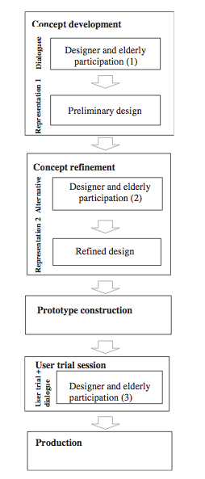

Figure 1: The USAP model flow chart; this is the basic methodology that I will be using to gather data (12).

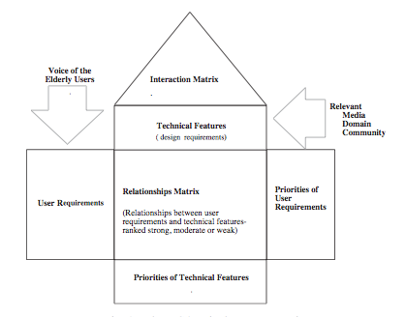

Figure 2: The design matrix that will be used to analyze data collected during sessions (12).

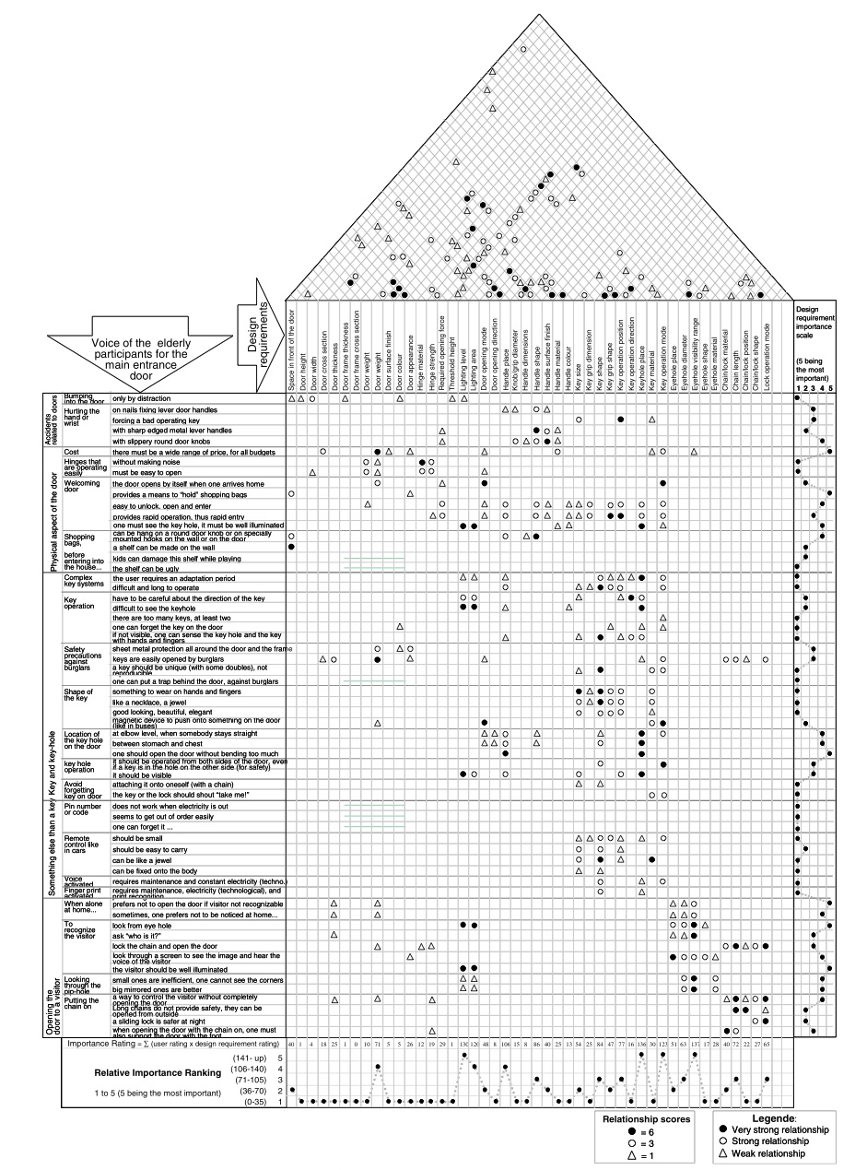
Figure 3: This is an example of a completed design matrix for a front door. Each element is assigned a value based on its importance/vitality in the design and in its relationship to other elements. Values for each row and column are summed to determine which elements should take priority in the product’s design (12).
List of Sources:
1. Herstatt, C., Kohlbacher, F., and Bauer, P. (2011). "Silver" Product Design - Product Innovation for Older People. Retrieved February 11, 2015
2. OECD – Organisation for Economic Co-operation and Development, Paris. (1998) Maintaining Prosperity in an Aging Society. Retrieved February 11, 2015
3. Metz, D. (2000). Mobility of Older People and Their Quality of Life. Transport Policy, 7, 149-52. Retrieved February 1, 2015
4. Jarvis, C., Hancock, R., Askham, J., Tinker, A. (1996). Getting around After 60: A Profile of Britian’s Older Population. Retrieved February 3, 2015
5. Lunsford, D., and Burnett, M. (1992). Marketing Product Innovations to the Elderly: Understanding the Barriers to Adoption. Journal of Consumer Marketing, 9(4), 53 – 62. Retrieved February 1, 2015
6. Mann, W., Hurren, D. and Tomita, M. (1993). Comparison of Assistive Device Use and Needs of Home-Based Older Persons With Different Impairments. The American Journal of Occupational Therapy, 47(11), 980-87. Retrieved February 1, 2015
7. Bateni, H., and Maki, B. (2005). Assistive Devices for Balance and Mobility: Benefits, Demands, and Adverse Consequences. Archives of Physical Medicine and Rehabilitation, 86(1), 134-45. Retrieved February 2, 2015
8. Nussbaum, B. (1993). Hot Products. Business Week, 54-57. Retrieved February 17, 2015
9. Bloch, P. (1995). Seeking the Ideal Form: Product Design and Consumer Response." Journal of Marketin,g 59(3), 16-29. Retrieved February 1, 2015
10. Jordan, P. (1998). Human Factors for Pleasure in Product Use. Applied Ergonomics, 25(1), 29-33. Retrieved February 17, 2015.
11. Demirbilek, O, and Demirkan, H. (1998). Involving the Elderly in the Design Process. Architectural Science Review, 41(4), 151-163. Retrieved February 1, 2015
12. Demirbilek, O, and Demirkan, H. (2004). Universal Product Design Involving Elderly Users: A Participatory Design Model. Applied Ergonomics, 35, 361-70. Retrieved February 1, 2015

