Open Scheduling – Elon Students
MyChart

From your phone or laptop Browse to https://mychart.conehealth.com/mychart
Click on New Patient Scheduling
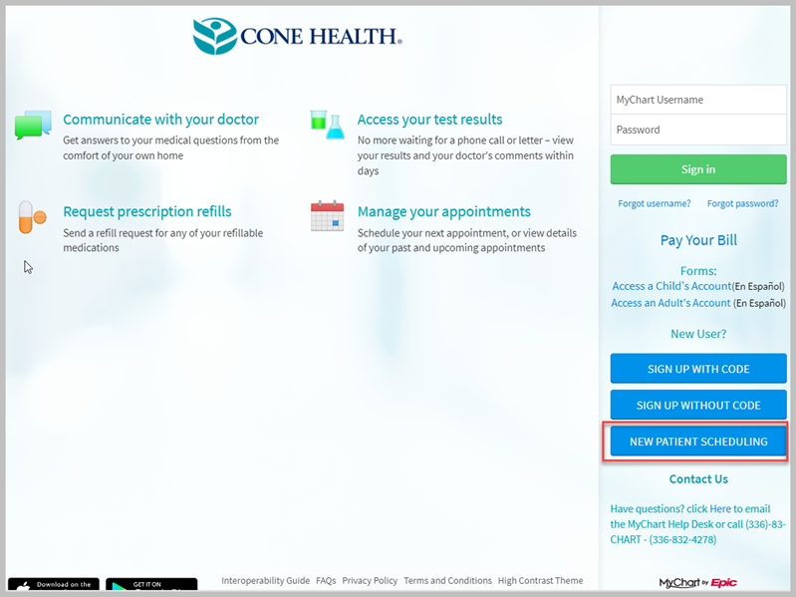

Click on Occupational Medicine – Elon Students and Faculty
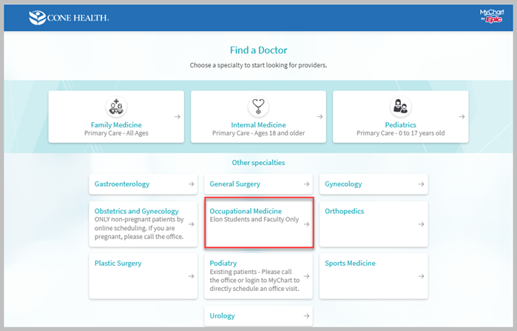
Click on Office Visit
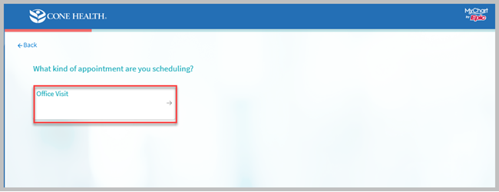

Click on Elon University Student Wellness Center, Continue
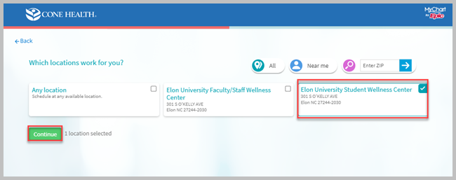

Choose a Date and Time for your appointment
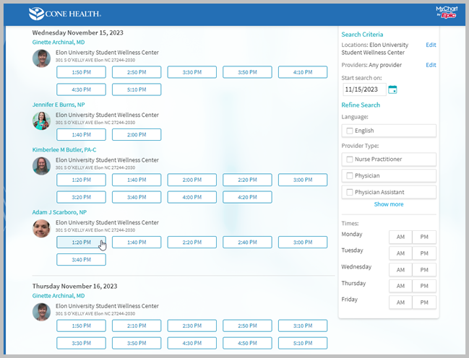

Answer the Captcha
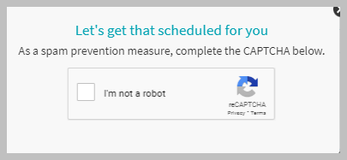
Fill in what the appointment is for, then Log in and schedule
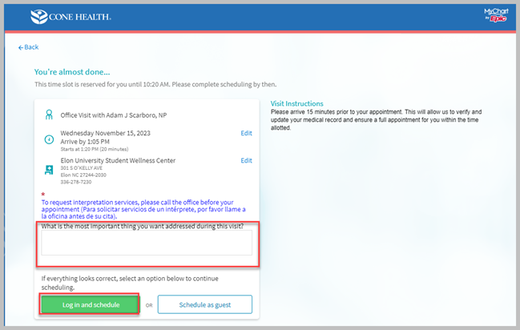

Enter your MyChart username and password
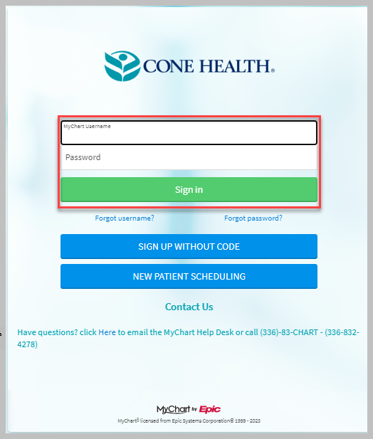
After login you will see the appointment details, Confirm appointment and Complete eCheck-In
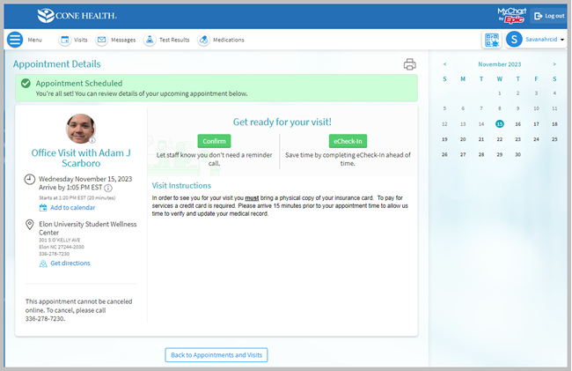
Click on Visits to see details of your appointment
