Semester Request Process in Accommodate

On the Accommodate homepage, click on the “Accommodation” tab and select “Semester Request” to begin the process.

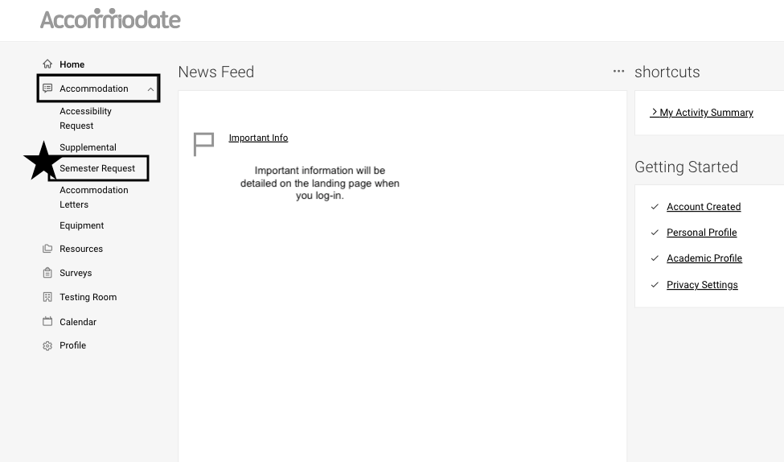

Select the Appropriate Term from the dropdown menu. Click “Add New” to continue.

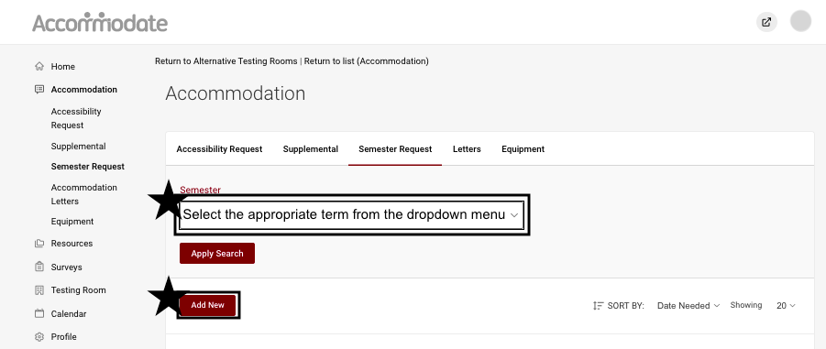

Review ALL accommodations that you have been approved for. Double-check that you have selected the appropriate semester. Your courses will automatically populate on the right-hand side of the screen. Click “Submit For All Accommodations” to process your semester request.

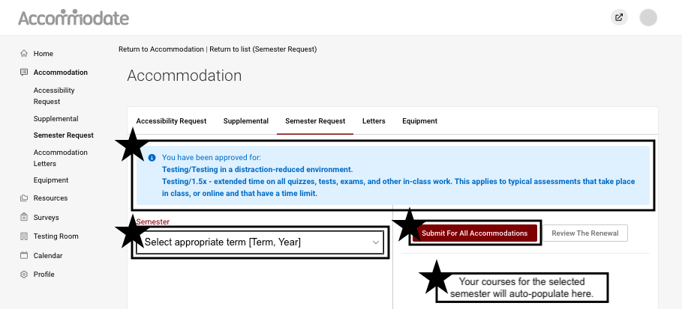

Disabilities Resources will then be notified of your request. Upon review of your semester request, you will receive either your Accommodation Letter for the Term you selected, or an email from the Disabilities Resources Office regarding your status.

If you need to request additional accommodations, you will need to submit a “Supplemental” request for review.

As always, if you have any questions, please reach out to DR @ 336.278.6568, or by email, disabilities@elon.edu!

