Three Meals A Day Keeps the Doctor Away
Tips for Eating Three Meals A Day in College

By Caitlin Hoyt
December 13, 2019

My mom was always an advocate for eating whatever, whenever. It wasn’t until I was officially diagnosed with an eating disorder that I realized how I had been eating was not helping my weight. Growing up, we easily responded to food availability rather than food quality. Bag of chips in the cabinet? Absolutely. Out shopping with Mom at the mall with a McDonalds? Chicken nuggets for lunch it is. Here are some tips for how to eat with a “less is more” mindset in college.

Breakfast
Meal Prep, Meal Prep, and did I say Meal Prep?

Our weeks are busy, I get that. Things come up at the last minute. Professors assign work that makes you feel like you’re drowning. On top of that we are expected to get a good night’s sleep, eat well, maintain good grades, and have a social life. It’s a never-ending choosing game. More often than not, we choose to skip meals here and there to fit everything else in. Why not use Sunday’s as a meal prep day? Make yourself a large smoothie with fruits, veggies, and protein powder, throw it in the freezer, and voila! You have yourself breakfast for the week to come. The best part about it is that it is easy to have on-the-go. Maybe you’re not a smoothie person – options like Overnight Oats and protein bars exist to give you the right amount of energy to get you through your morning.

Lunch
Don’t have time? You’re still fine!
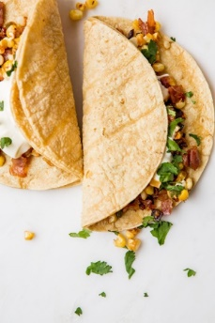
Many of us are running from class to class during the day with only 15 minutes to get from one place to the other. Now is the time to use last night’s leftovers from dinner with your friends. Did you know that a Chipotle burrito bowl is just as good, if not better (in my opinion) cold the next day? Eating leftovers not only saves you an additional $10 that you would’ve spent on Biscuitville, but it also saves you from the embarrassment of having your stomach growl in the middle of your Media Law class.

Dinner
Spice up your meal with some veggies

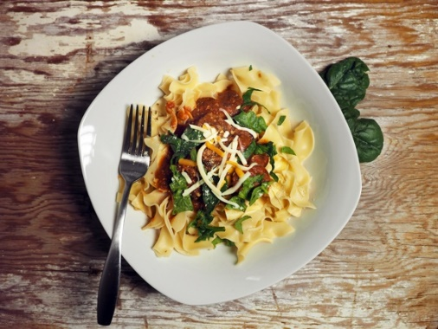
After a long day, the last thing we want to do is cook a full blown homecooked meal that Mom makes. Let’s be real, Mom’s probably tastes so much better anyway. So instead of taking out that chicken that you’ve had in the freezer for over a month, you crack open that box of pasta and cook nearly half of it. Try buying some fun veggies the next time you’re at the grocery store. Harvard Health recommends replacing 1 cup of pasta with ½ cup of pasta and 1 cup of broccoli. This will actually save you 100 calories, if that’s that you’re into.

