You have to eat WELL to be WELL
5 tips on how to eat healthy in college without a meal plan

Dec 13, 2019
By Serena Shah

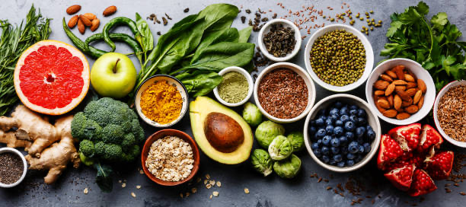

College students are notorious for being stressed, overworked, and tired. The lack of time and a limited budget can cause college students to eat unhealthy food.
At some point, we have all come home after a long day of classes to realize we have no food. What’s worse is that we also don’t have a dining plan to fall back on. Instead of going to the grocery store, we end up eating unhealthy and non-nutritious foods.
What is “eating healthy”?
It is hard to eat healthy without knowing exactly what that means. Eating healthy is not about setting strict limitations on what food you can and cannot eat. It is also not about trying to get a certain body image. Eating healthy food is about “having more energy, improving your health, and boosting your mood.”
Eating healthy includes eating whole foods, reducing your sugar intake, and eating foods that have a high amount of nutrients. Whole foods are foods that only have one indigent like a chicken breast or an apple.

How to eat healthy without a meal plan?
Eat low cost nutrient rich foods:
Most college students have a limited budget, which makes grocery shopping more difficult. Healthy foods are often more expensive than processed foods. But, I’m here to tell you that there are lots of low cost healthy foods.
Foods like sweet potatoes, lentils, quinoa, oats, broccoli, and eggs are inexpensive and rich in nutrients. These foods will help you stay full, have more energy, and they even have health benefits.

Plan your meals:
Nothing is worse than coming home after an exam and two lectures to find out that you have no food.
Take 20 minutes on a weekend morning to create a meal plan for the week. This will make you feel more organized and helps to save time and money. Meal plans also reduce the risk of getting fast food or skipping a meal.
The USDA has created a program to help people eat healthy on a budget. Click here for resources to help plan meals, make grocery lists, and get ideas for healthy and budget-friendly meals.

Make enough food for leftovers:
Cook once and eat twice!
Making dinner takes time, even if you’re making a quick recipe. Cooking large meals and eating the leftovers will help you save money and time during the week.

Cut up your vegetables and prep your other food:
After unpacking your groceries, take 15 minutes to cut up the produce and prepare any other items.
Cutting all of your vegetables and putting them in containers makes healthy snacking easy. It will take some extra time to cut up everything, but it will be time well spent.

Limit the amount of sugar you eat:
Be aware of the added sugar you’re eating throughout the day. Look at the nutrition labels on packaged food and drinks to see how much sugar it has.
The American Heart Association say, the daily limit of sugar for women is 25 grams and 36 for men. For perspective, a Pumpkin Spice latte at Starbucks has 50 grams of sugar.

https://www.helpguide.org/articles/healthy-eating/healthy-eating.htm

