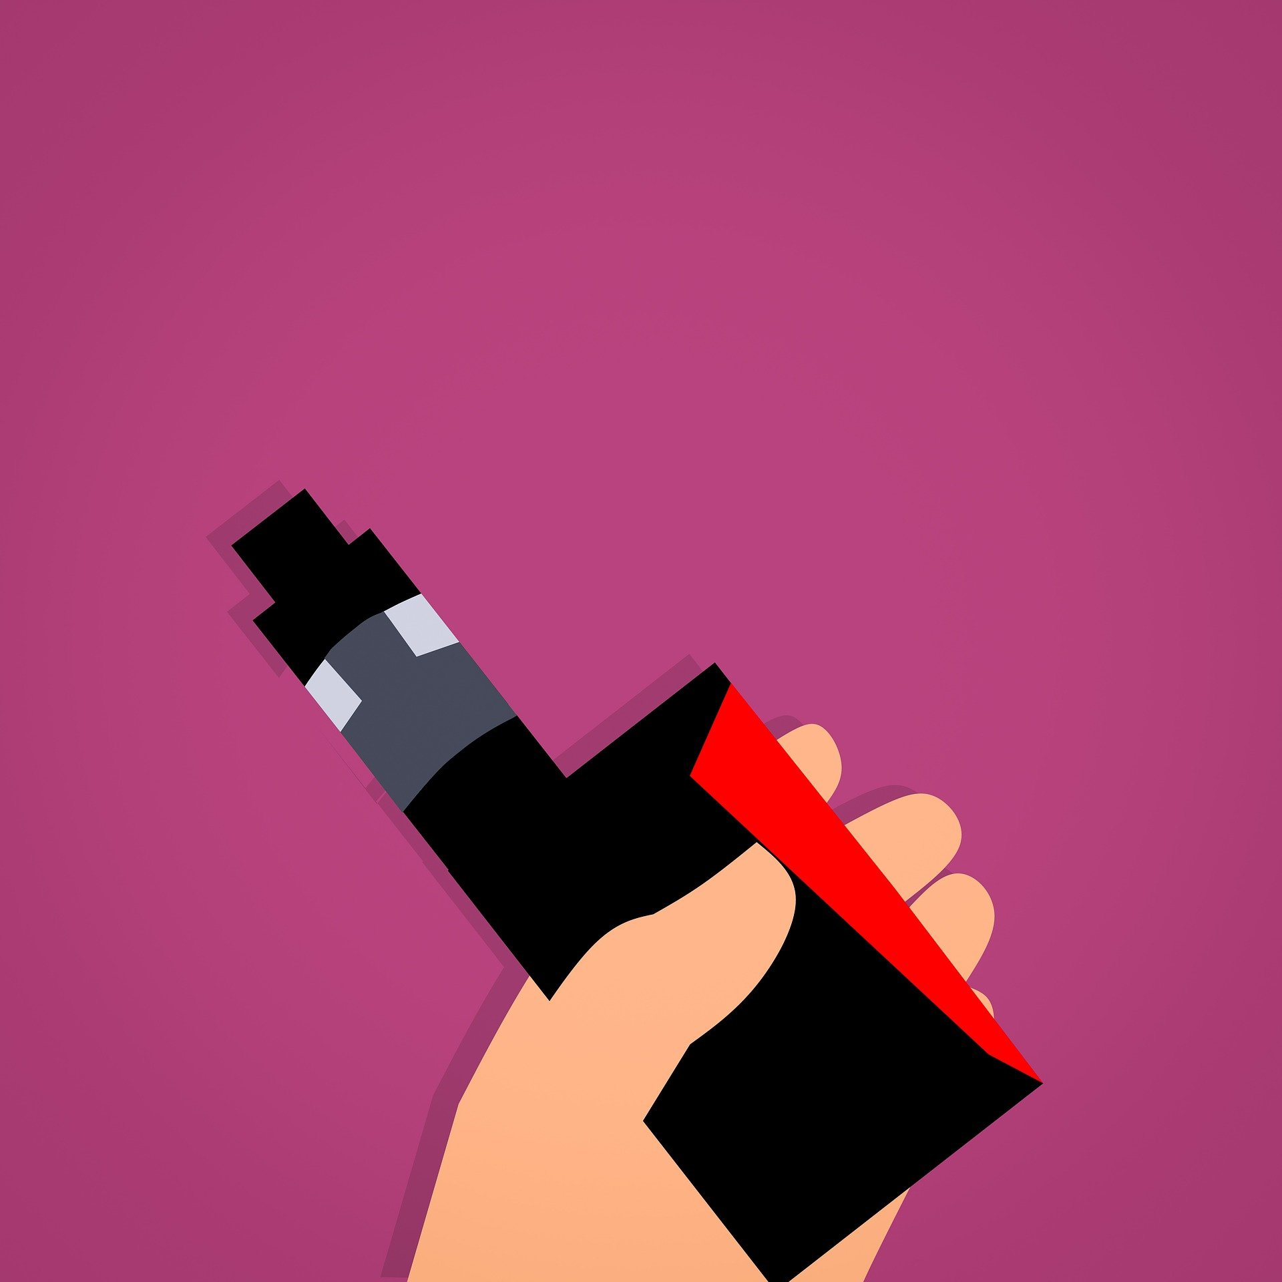
Quit Vaping For The Sake Of Your Independence - Four Reasons Why Vaping Will Decrease Your Independence As An Adult
By Bay Shuford and Carly Kleinwaks

Vaping came on the scene as an alternative to the traditional way of smoking cigarettes - now, it has exploded into its own market; different flavors of vape fluid, different technologies and ‘rigs’ to smoke from, and an entire culture that has dedicated itself to the supposed ‘healthy smoking alternative’. But the question must be asked, is it healthy to have an addiction that can sever your independence on multiple fronts? The addiction to vaping has been compared to that of traditional cigarettes, with one exception: the average vaper falls between the ages of 13-25, an age where the mind is still developing and where oftentimes, the full independence of the teen or young adult has not been actualized. Here are the four reasons why vaping can impact future independence in teens and young adults.

- Medical Independence
The concept of being medically independent is not one that most people tend to consider when talking about their personal freedoms and abilities. For the target audience of vape users, they see themselves as young, healthy, and practically invincible; medical independence is nothing to worry about, not yet at least. However, being hooked up to a rebreather as a result of a severe lung injury is a serious detriment not only to personal health, but also to independence. Lung injuries from smoking and vaping kill people everyday, including many teens. According to singlecare.com, there have been 2,807 hospitalized cases of severe lung injury connected with vape products, resulting in 68 deaths as of February 2020.

- Social Independence
The addiction to vaping can lead to strains on friends and family, especially those who do not support the vaping habit. Although we may try not to think about what other people think about us, it can still have an impact on confidence levels and social attitudes for the individual. Social perceptions of the vaping individual may change due to the nature of the addiction; these social perceptions can then lead to feelings of isolation and depression at the loss of potential interactions or loss of relationships.

- Financial Independence
Most vape users know of or have bought Juul products, which was one of the first brands to offer chargeable nicotine devices. The company offers refill pods for about $5 and the rechargeable Juul battery for around $20. Although each pod refill purchase may only cost around $5, a regular Juul user will spend $1,008 per year on the products, according to aces.edu. For comparison, one year of Juul expenses equals the same price as a Caribbean Cruise.

- Mental Independence
Vape use can lead to many serious mental health issues. According to changetochill.org, vaping has been shown to change behaviors in young adults such as impulse control. Ultimately, this can lead to mood disorders, and permanent injury to parts of the brain that control your memory, emotion and critical thinking.

With this information, hopefully you can make an informed decision to stop vaping. Although it may be hard, there are many resources such as changetochill.org that you can use or share with a loved one who is struggling with the idea of quitting.

