Buzzed? Don’t Drive: Keeping Saturdays at Elon Fun & Safe How Buzzed Driving is the Real Buzzkill
By Jocelyn Clendening
Picture this: it’s a Saturday at Elon in the spring, sunny and 70 degrees out. You may have had a drink (or two). You and your friend want to go hang out somewhere across campus. Your friend says, “Great, I’ll drive!”
Your instinctual reaction is, that’s probably not a good idea. But it’s hot, and you’ve already worked out earlier in the day, so it’s easier to just drive than to walk. Everyone is smiling, laughing, and enjoying the day -- you don’t want to be the one to speak up.
It’s not technically drunk driving, and it's just across campus. So it’s fine, right?
This hypothetical situation probably felt very real to you, because it’s likely that you’ve experienced something very similar to this. You’re not alone.
What is “Buzzed Driving”?
It is widely known and accepted that drunk driving is a bad and dangerous decision; however, “buzzed” driving is becoming a problem amongst college-aged young adults. A survey by American Addiction Centers found that over 69 percent of respondents admit to driving after consuming some alcohol. More specifically, 65 percent said they believe it’s safe to drive after two drinks, and 15 percent said it's OK to drive after four drinks (Drinking and driving habits).
While it is still technically legal to get behind the wheel with a BAC of 0.07 or less, just one alcoholic drink can impair a person’s ability to drive safely. This is a massive health risk to young and impressionable college students, many of which are being exposed to drinking for the first time upon arrival to college.
Here is a three-step process that can help you make decision whenever you find yourself in a situation like this:
1. Trust your gut.
Think back to your first thought -- “that’s probably not a good idea.” It’s important to pay attention to your gut instinct, which usually tells you when something feels right or wrong.
2. Consider risk & reward.
“It’s just across campus.” Exactly! A three minute drive can roughly equal a fifteen minute walk. What is a fifteen minute walk in comparison to potentially harming yourself and others on the road, or potentially racking up $10,000 in legal fees for a DUI (National Highway Traffic Safety Administration)?
3. You’re not the buzzkill.
Don’t worry about killing the fun by speaking up. In fact, you’re the one keeping everyone safe while having harmless fun.
Next time someone around you is considering driving while buzzed, remember these three simple steps. Want to be part of this movement? Post these graphics on your Instagram story, and tag us @therealbuzzkill!
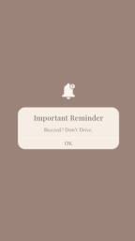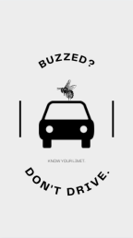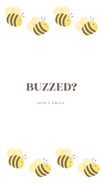
References
Drinking and Driving Habits. Alcohol.org. (n.d.).
https://www.alcohol.org/guides/drinking-and-driving-habits/.
National Highway Traffic Safety Administration. (n.d.).
https://www.nhtsa.gov/campaign/buzzed-driving.
Readability score calculated on:
https://readabilityformulas.com/freetests/six-readability-formulas.php

