What is Binge Drinking?
Drinking alcohol has been a part of college culture forever. Though many students are unaware of the dangers of drinking too much, a practice is known as binge drinking. The National Institute on Substance Abuse and Alcoholism (NIAAA) describes binge drinking as a trend of consuming alcohol that results in a blood alcohol concentration (BAC) of 0.08 percent—or 0.08 grams of alcohol per deciliter—or higher. This trend corresponds to drinking 5 or more drinks (male) or 4 or more drinks (female) in about 2 hours for a typical adult. Drinking this way will result in traffic accidents, drunk-driving convictions, sexual assaults, and injuries, among other things. Frequent binge drinking can damage the liver and other organs in the long run. Many students come to college expecting to drink in large quantities every weekend. Those who have not built a tolerance for alcohol are most at risk for the danger related to binge drinking.

According to a recent survey pictured below, half of the individuals surveyed admitted to binge drinking while in college. The thing about binge drinking is that it not only affects college students but also affects their families and college communities.
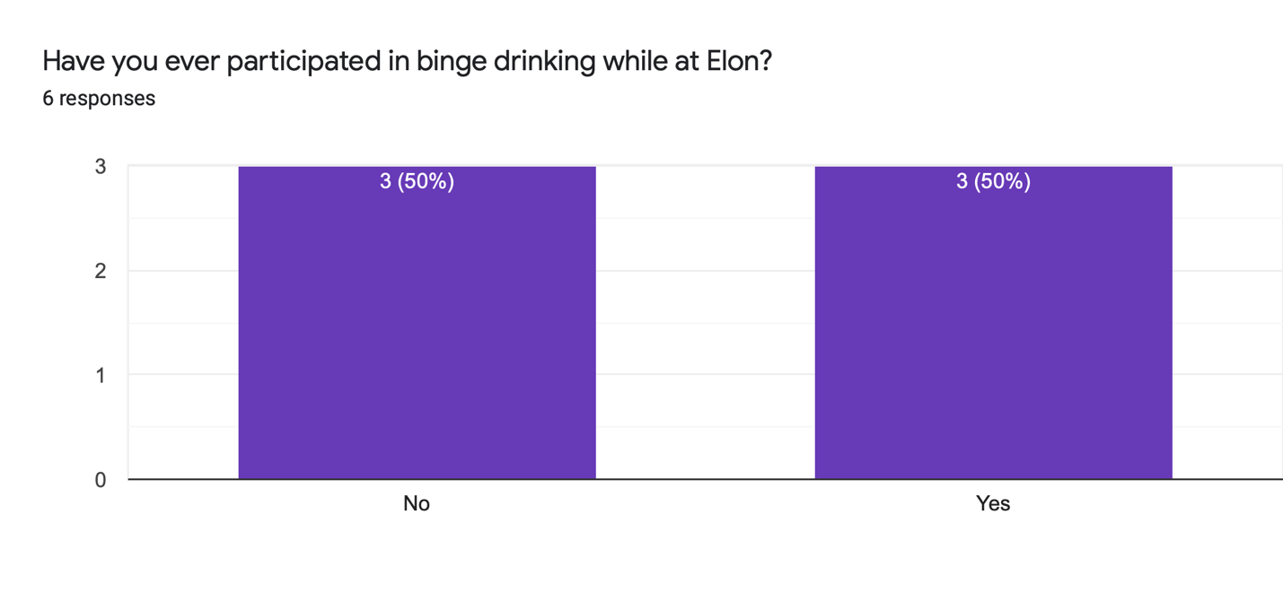

Harmful and Underage College Binge Drinking Consequences

Death
According to the NIAAA, approximately 1,519 college students aged 18 to 24 die each year from alcohol-related accidental incidents, such as car accidents.

Sexual Assault
According to the most recent NIAAA estimates, about 97,000 students aged 18 to 24 have experienced alcohol-related sexual harassment or date rape.

Academic Consequences
According to a recent study, alcohol intake was found to have detrimental effects on academic motivation and subjectively earned grades. Alcohol prevention programs at universities can have a positive effect on students' academic performance.
According to a study done by St. Lawrence University, students who drink heavily the night before will have positive blood alcohol levels the next day, influencing whether or not they show up for class and, if they do, the consistency of how information is interpreted and eventually stored.
Sleeping off a buzz, which is a common practice among college students, can disrupt the sleep cycle, causing anxiety, jitteriness, and irritability the next day, as well as fatigue the next.

Alcohol Use Disorder
According to a national survey conducted in 2019, about 9% of full-time college students aged 18 to 22 meet the requirements for past-year AUD.

What is the biggest contributor to Binge Drinking?
When a group of students was asked what contributes to whether they decide to drink on a certain night, every single one of them responded with something related to their friends or the people they are with. Peer pressure, intended or not, is something that usually is attributed to underage and binge drinking in the college years. Many students feel that to “fit in” or “feel included” within the college lifestyle they need to drink. But this does not need to be the case going forward!

What Can Students Do Instead of Binge Drinking?
The same group of students was also asked if any other activities gave them the same type of feelings they get from drinking, and some of their answers include:
- “Hanging out with my friends on a chill night.”
- “Listening to music”
- “Watching my favorite tv show or movie”
- “Playing the ukulele”
______________________________________________________________________________
Next time you are thinking about drinking, ask yourself what you could do instead to get the same satisfaction!

Going Forward
The purpose of this article is not to stop drinking at college completely. That is something that will most likely never stop. Students just need to be safer and smarter about how much they drink. Having one or two drinks on the weekend is very reasonable. Students also don’t need to drink EVERY weekend. Students don’t need to drink in order to have a good time. Going forward students should take a moment and think, “Am I drinking because I want/need to or because it is just expected that I drink?”

