What’s More Important To College Students: Mental Health or Technology?
By Liddy Custer

Mental Illness negatively affects one’s mood, thinking, and behavior and can create problems in one’s everyday life. Mental Illness affects one in every 5 U.S adults in America (an estimated 26%). Anxiety is the most common mental illness that affects approximately 18% of the population, however, only 36.9% receive treatment. Depression affects 3.1% of the population, however, only 43.2% receive treatment. Mental illnesses like these have a debilitating impact on our lives and can also cause physical health issues as well, and 26% of Americans suffer from this (ADAA 2020). It appears that many people are educated on the issue of mental illnesses affecting Americans everyday lives, especially in college students.
I conducted my own study targeting college students regarding their knowledge on mental illness. A diverse group of 5 students helped me confirm the information I researched on the subject. Most of my research subjects guessed that 20-25% of Americans suffer from mental illness. This shows that they are in fact educated on the statistics of mental health. However, a lot of them did state that there are many undiagnosed cases that go unnoticed from this statistic. One of my subjects gave the number of 60% total when including those on the undiagnosed side. When it comes to receiving treatment, it was clear that my research subjects do not think many actually receive treatment. It is important to note that all of my research subjects stated that they have suffered from anxiety or depression in their lifetime, and only 2 out of 5 (40%) have received treatment. This research backs up the statistic from the National Institute of Mental Health, stating that only 36.9% receive treatment.

What causes an increase in mental illness in college students?
In a research study done by Andrew Leep, Jacob Barkley, and Aryn C.Karpinski the “typical cell phone users may experience some level of anxiety as a result of perceived obligation to remain constantly connected with others”(Leep,Barkley,Karpinski). College students feel the constant need to feel connected to their peers and in result their anxiety increases. It seems that “previous research has already suggested that high frequency cell phone users are less physically active”(Leep,Barkley,Karpinski). Because social media is known to increase anxiety levels, it is extremely important for college students to decrease their cell phone use. Not only does technology increase anxiety and depression, it is a common and easy way for college students to hide their emotions and avoid their problems. The graphic I created below emphasizes how technology only increases anxiety and depression levels.

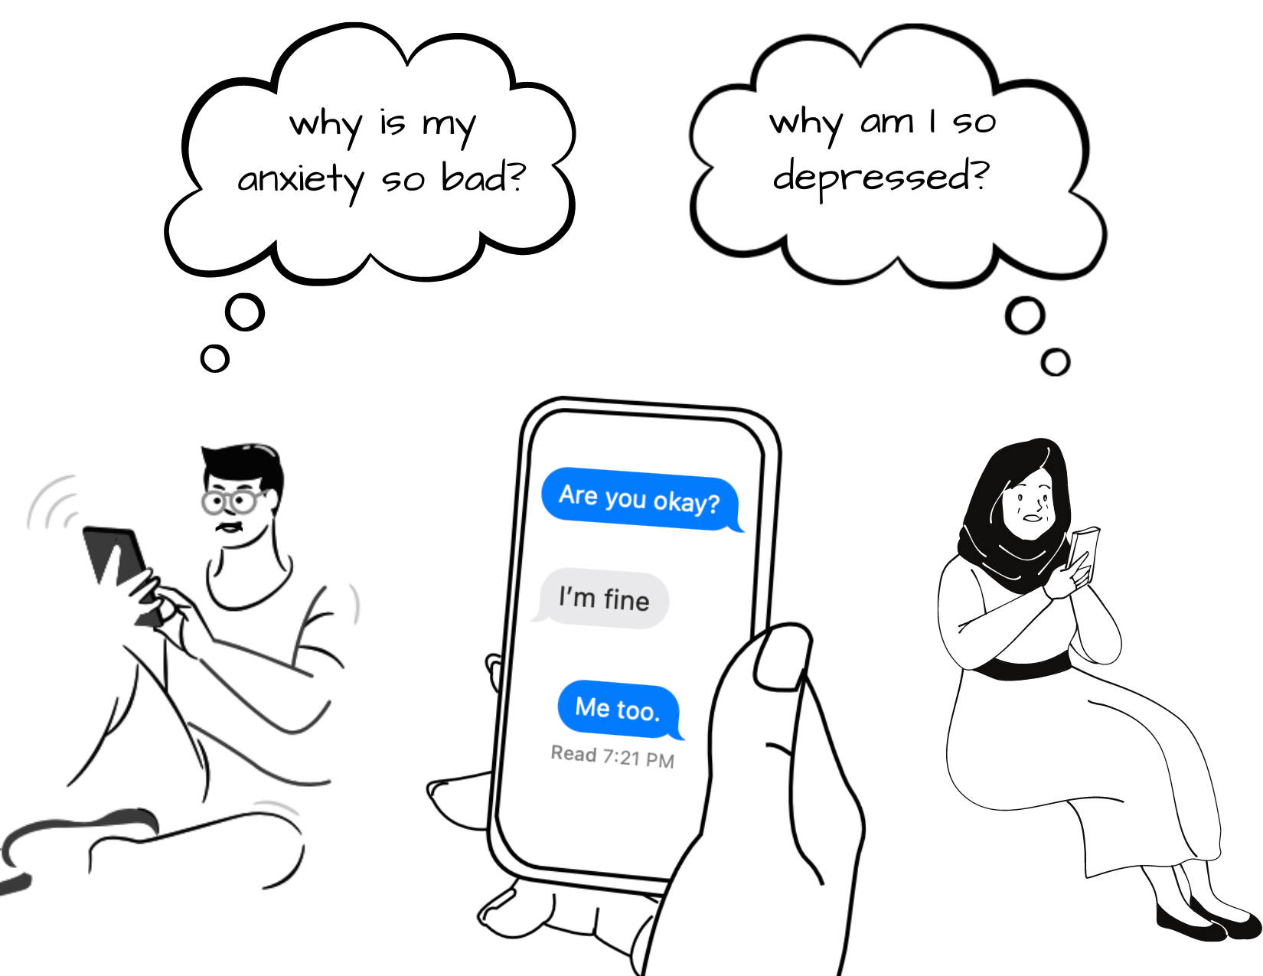

So what can we do to decrease the use of technology by college students? The first step is to understand the seriousness of the issue. Because technology is advancing more quickly than ever, screen time will inevitably increase. Students should take the time to have more one-on-one communication. Because we can see the clear connection between increasing mental illnesses and technological advancements over the past 20 years, we are aware of what we need to do to fix the problem. It is now in the hands of the cell phone user to decide whether or not screen time is more important than their mental health.

Works Cited

Lepp, Andrew, Jacob E. Barkley, and Aryn C. Karpinski. "The relationship between cell phone use, academic performance, anxiety, and satisfaction with life in college students." Computers in human behavior 31 (2014): 343-350.

