Taking the Screen Out of Your Nighttime Routine: Your 5 Day Blue Light Break Challenge
Studies show that the blue light admitted by electronic devices can be detrimental in getting the energizing sleep you need. Don’t panic, that's why we have created a 5-day pre-bedtime digital detox.
By Isabel Allain and Madison Burrill
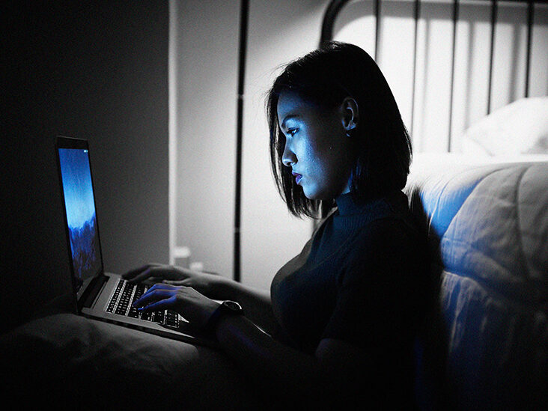
College junior, Sarah Lynch, is a frugal student who works two jobs in order to pay her way through college. Nonetheless, every week she lets her hard-earned money go to waste on caffeinated beverages that she hopes will keep her awake. But what if there was a way that Sarah could feel more energetic while becoming less reliant on pricey coffees?
The answer may seem too simple: increasing sleep quality by putting your laptop or phone away before bed.
Maintaining an appropriate sleep schedule should be of top priority, especially for college students like Sarah who have busy schedules. Research has shown that increased screen time usage before bed inhibits restful and quality sleep. By merely reducing screen time before bed, students can cultivate a higher quality sleep schedule.
Why Do Electronics Affect Your Sleep?
Humans follow a natural sleep-wake cycle that takes cues from the sunlight to determine when to produce melatonin, the ‘sleep hormone’. The blue light produced by electronic devices such as smartphones, computers and televisions imitate sunlight, tricking your body and disturbing the cycle.
Unfortunately, getting off your beloved electronics is easier said than done. That's why we came up with a 5-day program to get you started.

5 Day Blue Light Break Challenge
- DAY ONE
We are so glad that you decided to accept this challenge! Today we are going to lay the ground for the rest of your detox through a few journal prompts. A study that interviewed college students found that journaling reduces worry and stress before bed, increases sleep time and improves sleep quality.
Below are journal prompts that will serve as a reminder of where you started:
- What is your biggest concern with this challenge?
- What made you accept this challenge?
- DAY TWO
If journaling is not your thing, no worries! Today we are going to try yoga. According to Healthline, yoga before bed alleviates insomnia, aids in weight loss, improves sleep quality, promotes relaxation, and improves quality of life.
Click HERE for a 12-minute yoga video.
- DAY THREE
Make some tea or pour yourself a glass of wine! Surprisingly enough, studies show that individuals who drank 5 oz. of red wine every night reported better sleep quality than those who drank water.
If you would rather opt for a non-alcoholic beverage, have no fear! Tea has even better benefits. Chamomile tea, for example, contains antioxidants that may promote sleepiness, and drinking it has been shown to improve overall sleep quality.
- DAY FOUR
It’s time to focus on moving your body in a way that promotes good sleeping habits.
Stretching before bed can help reduce body pain, stress, boost your mood and improve circulation. Try these two simple stretches before bed tonight!

- The bear hug
GIF from greatist.com
- The head roll
GIF from healthline.com
- DAY FIVE
You made it, congratulations! Be proud of yourself for making it 5 days without giving into the temptation of your screen.
Take time to reflect on the past 5 days in a final journal entry:
- Was it easy for you to give up your electronics before bed?
- Did you notice a difference in your sleep?
Now What?
We hope you had a positive experience with this program and feel more energized than when you began! While it takes longer than 5 days to create a habit, this program is designed to get you off your electronics and thinking about the importance of sleep quality.

